|  |  |
| --- | --- |
|  | **FPT ACADEMY INTERNATIONAL**  **FPT – APTECH COMPUTER EDUCATION** |

**Centre Name: ACE-HCMC-2-FPT.**

**Address: 590 Cach Mang Thang 8, District 3, Ho Chi Minh City, Viet Nam.**

Ice Cream Shop Management System

|  |  |  |
| --- | --- | --- |
| **Supervisor:** | Ms. Le Mong Thuy | |
| **Semester:** | 3 | |
| **Batch No:** | T1.1804.M1 | |
| **Group No:** | 5 | |
| **Order:** | **Full name** | **Roll No.** |
| 1. | Bui Van Huong | Student1093630 |
| 2. | CHAU THANH PHONG | Student1088413 |
| 3. | DANG NGUYEN DAN LINH | Student1053724 |
| 4. | LY TIEN DAT | Student1093706 |
| 5. | MAI HOANG MINH TIEN | Student1057354 |

Month: July Year: 2019

**This is to certify that**

**Mr.** Bui Van Huong

**Mr.** Chau Thanh Phong

**Mrs.**Dang Nguyen Dan Linh

**Mr.** LyTien Dat

**Mr.** Mai Hoang Minh Tien

**Have successfully designed & developed:**

eProject: Book Online Management System

**Submitted by:**

Ms.Le Mong Thuy

**Date of issue:** July 11th 2019

**Authorized Signature:**

Contents

REVIEW 1 5

I. Acknowledgement 6

II. Problem Definition: 6

**1.** **Introduction** 6

Mr. “A” is the owner of the big Ice-cream parlor shop. He is famous for the taste and quality of the product they provide. As the number of customer is increasing day by day, the branches of the shop keeps on increasing. To popularize it more the owner of the company has decided to go for making the website of his shop. For this he has approached you to make the website 6

**2.** **Existing Scenario** 6

III. Requirement Specification 7

1. Customer's Requirement Specifications 7

**1.1.** **Order Book Receip Online** 7

**1.2.** **Read Book’s Receip Online** 7

**2.** **Functional Requirement Specifications** 7

**2.1.** **Function of User:** User can: 7

**2.2.** **Function of Admin:** Admin can: 7

**Note:** Constraint validation must be provided wherever necessary. And the website should have the smooth navigations. 8

**3.** **System Requirement Specifications** 8

**3.1.** **Server requirements:** 8

**3.2.** **Client requirements:** 9

**4.** **Development Software:** 9

**5.** **Technology:** 9

TASK SHEET REVIEW 1 10

REVIEW 2 11

I. Architecture & Design of the Project 12

1. Presentation Tier: 12

2. Business Logic Tier: 13

3. Data Access Tier: 13

II. Algorithms – Data Flowchart 13

2. Symbol generates: 13

**1.** **Main data flowchart for users** 14

**2.** **Purchase online for users have account and no account** 15

**3.** **Login process (For admins and users)** 15

**4.** **Logout process (For admin and users)** 16

**5.** **Insert User (For admin and users)** 17

**6.** **Update user’s information (For admin and users)** 18

**7.** **Delete User (For admin only)** 19

**8.** **Insert Recipe Ice Cream (For admin only)** 20

**9.** **Edit Recipe Ice Cream (For admin only)** 21

**10.** **Delete Recipe Ice Cream (For admin only)** 22

**11.** **Insert Book (For admin only)** 23

**12.** **Edit Book (For admin only)** 24

**13.** **Delete Book (For admin only)** 25

**14.** **Insert Book (For User only)** 26

**15.** **Edit Order (For admin only)** 27

**16.** **Insert Feedback (For user only)** 28

**17.** **Delete Feedback (For Admin only)** 29

III. Data Flow Diagram (DFD) 30

**1.** **Context Level Diagram** 31

**2.** **Level 0 DFD** 32

**3.** **Level 1 DFD** 33

**3.1.** **Administrators Manage Users** 33

**3.2.** **Administrators Manage Product** 33

**3.3.** **Administrators Manage Order** 34

**3.4.** **Administrators Manage Feedback** 34

**3.5.** **User Manage Users** 35

**3.6.** **User Manage Order** 35

**3.7.** **User Manage Feedback** 36

IV. Use Case Diagram 37

**1.** **Admin Use Case** 38

**2.** **Member Use Case** 39

V. Class Diagram 40

VI. Class Description 41

**1.** **Admin Class** 41

**2.** **User Class** 41

**3.** **Order Class** 42

**4.** **InvoiceDetailBook Class** 42

**5.** **Product Class** 43

**6.** **Feedback Class** 44

VII. Entity – Relationship Diagrams 45

**1.** **Entity – Relationship Diagram Symbols** 45

**2.** **Entity – Relationship Diagram** 45

**3.** **Entities and Properties** 46

**3.1.** **Customer** 46

**3.2.** **Admin** 47

**3.3.** **Feedback** 47

**3.4.** **Product** 48

**3.5.** **Order** 48

49

**3.6.** **InvoiceDetailBook** 49

**3.7.** **Recipes** 49

50

TASK SHEET REVIEW 2 51

REVIEW 3 52

I. DATABASE DESIGN 53

**1.** **Database Design Diagram** 53

**2.** **Database Structure** 54

**2.1.** **Table Admin** 54

**2.2.** **Table Customer** 54

**2.3.** **Table Feedback** 54

**2.4.** **Table Category** 54

**2.5.** **Table Product** 55

**2.6.** **Table Recipes** 55

**2.7.** **Table Order** 55

**2.8.** **Table InvoiceDetailBook** 56

II. GUI DESIGN 57

**1.** **User Interface** 57

**1.1.** **Home Page:** Introduce the website with the navigation bar links. 57

**1.2.** **Contact Us Page:** Show contact information of clinic & feedback form for user. (must login first to send feedback) 59

59

If send feedback successfully, a notification will appear, click to go back contact page: 59

59

**1.3.** **Login Page:** Login form for user 60

60

**1.4.** **Logout:** notification will appear when admin click logout button 61

**1.5.** **Register Page:** Register form for user if they haven’t account. 62

62

**1.6.** **Change Personal Information Page:** User can change their information here. 63

63

**1.7.** **Update Password Page:** User can change their Password here. 64

64

**1.8.** **Register Member Page:**If the user is not register ,user can fill value member is this profiles. 65

65

**1.9.** **Book Page:** This page display list of medicines, user can search item with search bar. 66

66

**1.10.** **Product Details Page:** This page display information of a product. User 67

also can add this product to cart 67

67

**1.11.** **Free Recipes:** This page display list of recipes for your user don’t use account. 68

68

**1.12.** **Full Recipes:** This page display list of recipes for your user register a member as month or year 69

69

**1.13.** **Detail of Recipes:** This page display the way to cook this favourite ice cream. 70

70

**1.14.** **FAQ Page:** This page display list of frequently of question. 71

71

**1.15.** **Your Cart Page:** Items which user had chosen will display here. 72

72

**1.16.** **Checkout page:** This page show for user confirm payment. 73

**1.17.** **InvoiceDetailBook:** this page display information about order user just bought 75

75

**1.18.** **Details of an order:** when user click details button in order details page, it will show details of it. 76

76

**1.19.** **Personal order history:** this page display history all orders of personal user. User can view it by click to menu “Order History” appears when user login successfully. 77

**2.** **Admin Interface:** 78

**2.1.** **Login Page**: Login form for admin (default: Username: **admin**, password: **123456**) 78

**2.2.** **Logout:** notification will appear when admin click logout button 79

**2.3.** **Change Password Page:** Admin can change password here 79

**2.4.** **Home Page:** has navigation bar links to all manage pages 80

**2.5.** **Category Management Page:** Admin can manage product here 81

**2.6** **Product Management Page:** Admin can manage product here 83

83

**2.7** **User Management Page:** Admin can manage user here 87

87

**2.8** **Order Management Page:** Admin can manage order here 90

**2.9** **Feedback Management Page:** Admin can manage feedback here 92

92

**2.10** **Recipes Manage Page:** Admin can manage recipe in here 93

3. SITE MAP 98

**1.** **Back-End Site Map** 98

**2.** **Front-End Site Map** 99

4. TEST PLAN/TEST CASE 100

5. CHECKLIST OF VALIDATIONS 101

6. SUBMISSION CHECKLIST 102

TASK SHEET REVIEW 3 103

# 

# REVIEW 1

# Acknowledgement

It is often said that “Gratitude is the sign of noble souls”. That’s why we devote this chapter to express our deep gratitude towards those who have supported and guided us to accomplish this eProject successfully.

First and foremost, we appreciate the invaluable assistance that our beloved instructor – Ms.Le Mong Thuy., has offered us. Whenever problems come up, she’ll always the one that we can count on for solutions. Moreover, there were moments when our team decided to give up our project, and Mrs. Thuy gave us a pep talk to keep us back on the track. Therefore, once again, we truly value your dedication and guidance, Mrs. Thuy.

Next, it would have been impossible to carry out and complete this project without the collaboration among our team members. Although we have gone through many obstacles during the project implementation, eventually we gained what we aimed at by our hard work, our strong commitment and of course, our brotherhood.

Finally, thanks to Aptech’s eProject assignment, we had a golden opportunity to apply what we have learnt into reality and gain hands-on experience which is essential for our future career.

1. **Problem Definition:**
2. **Introduction**

Mr. “A” is the owner of the big Ice-cream parlor shop. He is famous for the taste and quality of the product they provide. As the number of customer is increasing day by day, the branches of the shop keeps on increasing. To popularize it more the owner of the company has decided to go for making the website of his shop. For this he has approached you to make the website

1. **Existing Scenario**

This Application enables us to order book online even there is no necessary to login at the Book Online Management System,i.e. you can directly select many recipe Ice-cream and Dessert Book from the choices , read and order your favourite recipe in website . Application gives us the final output as with the amount to be paid.

**3. ADMIN:** There should be admin Login separate where the entire data of the application can be updated. Admin must maintain the client details and online transaction details. Even keep the track of the all the order activities carried like seminar, practical’s. When the administrator confirms the order it will proceed to the client

1. **Requirement Specification**

## Customer's Requirement Specifications

The site allows customer to choose the receip which was offered by the Online Book.

* 1. **Order Book Receip Online**
* Provide the list of common Book with Book type, book code, book name, category so that the customer can have many choice on my website.
* Accept order book online.
* Display the list items that customer chose.
  1. **Read Book’s Receip Online**
* Provide details of content of Book such as: receip, dessert,description etc.

1. **Functional Requirement Specifications**
   1. **Function of User:** User can:

* 1. Register.
* 2. Login, logout.
* 3. View description of product.
* 4. Search product.
* 5. Order product.
* 6. Check out order.
* 7. Cancel order.
* 8. Edit personal information or change password.
* 9. Send feedback.
  1. **Function of Admin:** Admin can:
* 12. Login, logout.
* 13. Add,update Book’s Recipe
* 14. Manage category.
* 15. Manage product.
* 16. Manage user.
* 17. Manage feedback.
* 18. Manage user’s order.

### **Note:** Constraint validation must be provided wherever necessary. And the website should have the smooth navigations.

1. **System Requirement Specifications**
   1. **Server requirements:**

* Hardware:

|  |  |
| --- | --- |
| Component | Requirement |
| CPU | Processor type:  Pentium IV-compatible processor or faster  Processor speed:  Recommended: 2.0 GHz or faster |
| OS | Microsoft Windows XP or higher with IIS |
| Memory (RAM) | RAM:  Minimum: 512 MB  Recommended: 2 GB or more |
| Hard Drive | Free space:  Minimum: 200 MB  Recommended: 50 GB or more  Maximum: Operating system maximum |

* Software:

|  |  |
| --- | --- |
| Component | Requirement |
| Microsoft .NET Framework | Version 4.5.1 |
| RDBMS | Microsoft SQL Server 2008 |

* 1. **Client requirements:**
* Hardware:

|  |  |
| --- | --- |
| Component | Requirement |
| CPU | Processor type:  Pentium III-compatible processor or faster  Processor speed:  Recommended: 1.0 GHz or faster |
| OS | All OS(Window ,Linux ,Android ,Mac OS …) |
| Memory (RAM) | RAM:  Minimum: 512 MB  Recommended: 1 GB or more  Maximum: Operating system maximum |
| Hard Drive | Free space:  Minimum: 10 MB |

* Software:

|  |  |
| --- | --- |
| Component | Requirement |
| Web Browser | IE 4.0 , Firefox 3.0,Chrome or Higher….. |

1. **Development Software:**

* Microsoft SQL Server Management Studio 2017.
* Microsoft Visual Studio 2017.
* Microsoft Visio 2016.

1. **Technology:**

* ASP.Net MVC 5.
* .Net Framework 4.5.1.
* Entity Framework 6.2.0.

# 

# TASK SHEET REVIEW 1

|  |  |  |  |  |  |  |  |
| --- | --- | --- | --- | --- | --- | --- | --- |
| **Project Ref. No.:**  **eP/Advertisement** **Portal Management** **System/01** | | **Project Title:** | **Activity Plan** **Prepared** **By:** | **Date of Preparation of Activity Plan:** | | | |
| **Sr.No.** | **Task** | **Actual Start** **Date** | **Actual** **Days** | **Team** **Mate** **Names** | **Status** |
| 1 | Acknowledgement | Ice Cream Shop Management System | Huong | 13/07/2019 | 1 | All member | Completed |
| 2 | Problem Definition | 13/07/2019 | 1 | All member | Completed |
| 3 | Requirement Specification | 13/07/2019 | 1 | All member | Completed |
| 4 | Task sheet review | 13/07/2019 | 1 | Liem | Completed |

|  |  |
| --- | --- |
| **Date: 13/07/2019** | |
| Signature of Instructor:  **Mrs. Le Mong Thuy** | Signature of Team Leader:  **Bui Van Huong** |

# REVIEW 2

1. **Architecture & Design of the Project**

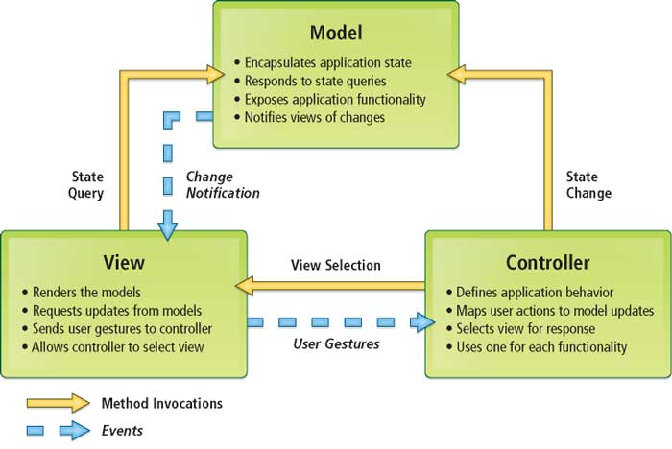

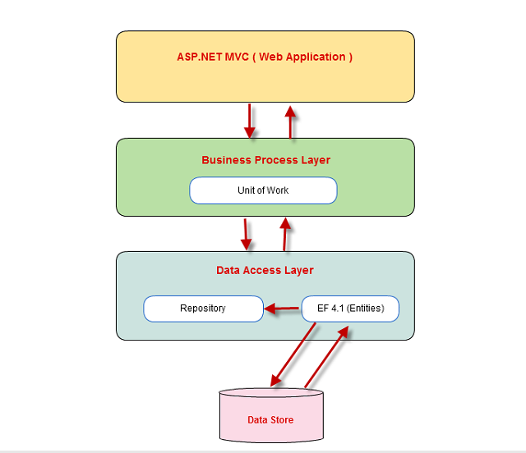

## Presentation Tier:

This is the tier in which the users interact with application. Presentation Tier contains Model, View, Controller used to receive a request and response to User.

Technology: ASP.NET MVC5, Razor, HTML, CSS, JavaScript, Ajax, JQUERY, Twitter Bootstrap

## Business Logic Tier:

Is mainly working as the bridge between Data Tier and Presentation Tier. All the Data passes through the Business Tier before passing to the Presentation Tier.

Technology: OOP, ASP.NET

## Data Access Tier:

This is basically the server which stores all the application’s data. Data tier contents Database Tables, Database Views and other means of storing Application’s data.

Technology: SQL Server, Entity Framework

1. **Algorithms – Data Flowchart**

## Symbol generates:



1. **Main data flowchart for users**

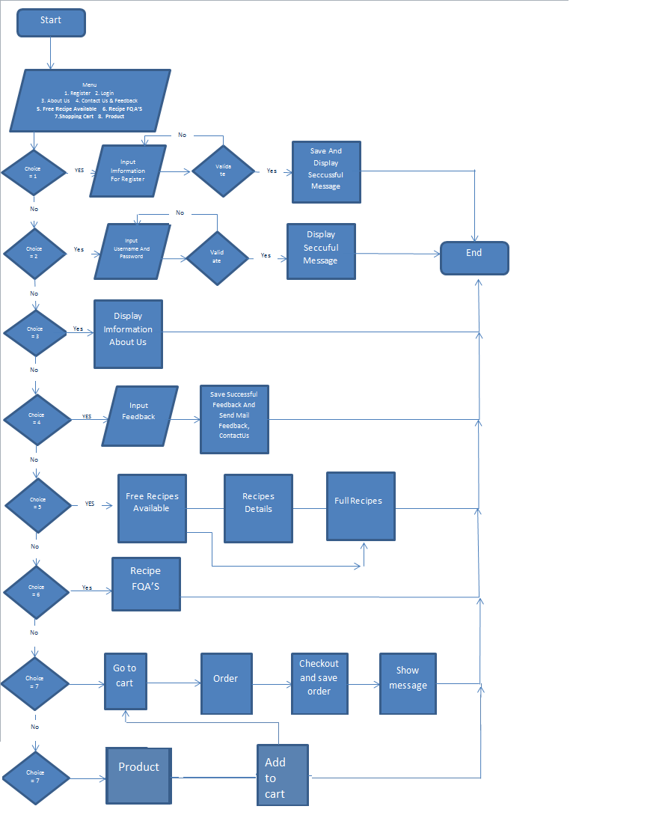

1. **Purchase online for users have account and no account**



1. **Login process (For admins and users)**



**Validate:**  
-Email: not null  
- Password: not null, min length: 6, max length: 100

1. **Logout process (For admin and users)**



1. **Insert User (For admin and users)**



**Validate:**

-Email: not null

- Password: not null, min length: 6, max length: 100  
- Name: not null, max length 20  
- Address: not null, max length 50  
- Phone: not null, only numeric, max length 15

1. **Update user’s information (For admin and users)**



**Validate:**  
-Email: not null

- Password: not null, min length: 6, max length: 100  
- Name: not null, max length 20  
- Address: not null, max length 50  
- Phone: not null, only numeric, max length 15

1. **Delete User (For admin only)**



1. **Insert Recipe Ice Cream (For admin only)**

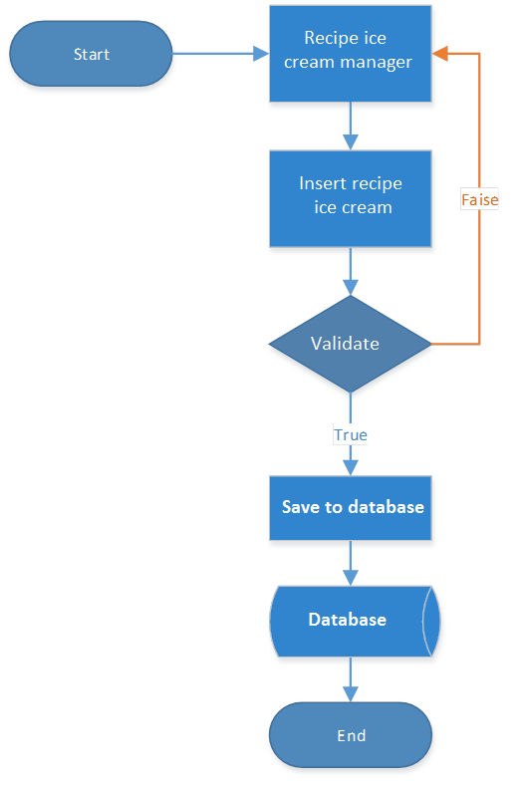

**Validate**

-Title:not null,MinLength(10) max length 100

- Description: not null, min length30,max length 90

Link Image:not null

-Link video:not null

-Status:not null

1. **Edit Recipe Ice Cream (For admin only)**

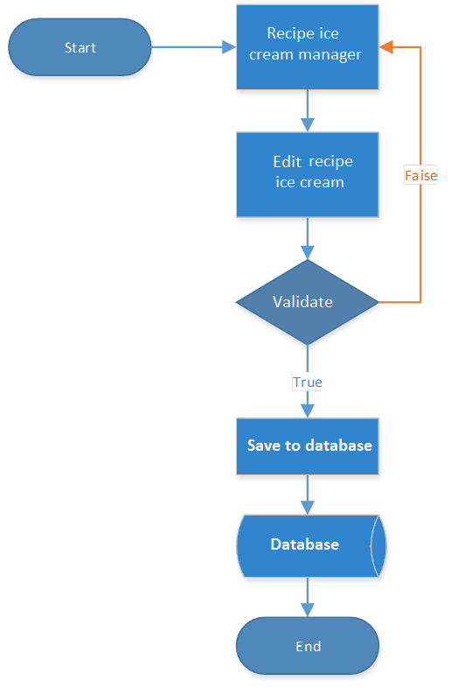

**Validate**

-Title:not null,MinLength(10) max length 100

- Description: not null, min length30,max length 90

Link Image:not null

-Link video:not null

-Status:not null

1. **Delete Recipe Ice Cream (For admin only)**

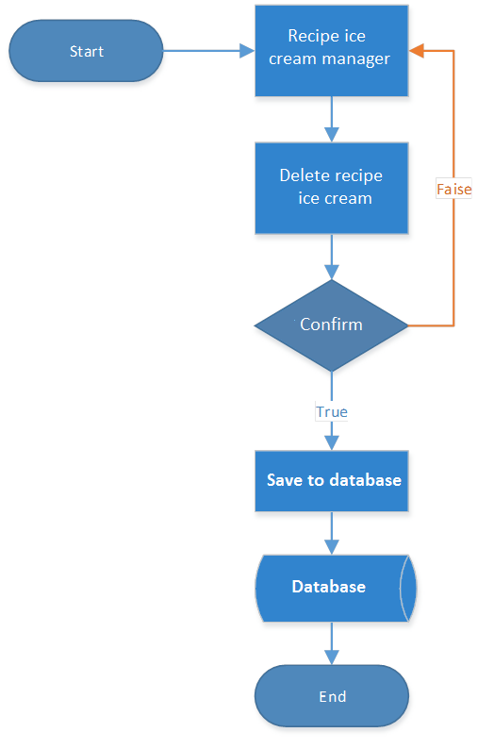

1. **Insert Book (For admin only)**

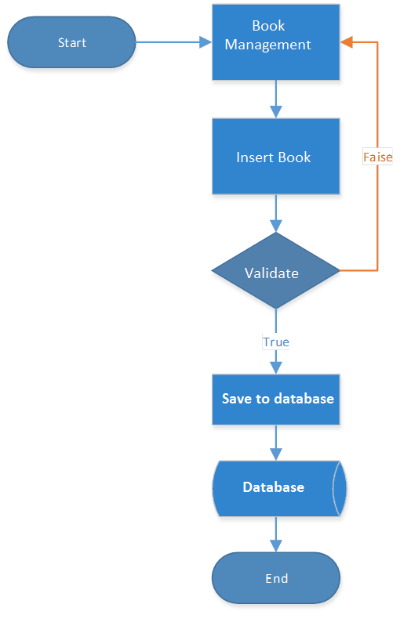

1. **Edit Book (For admin only)**

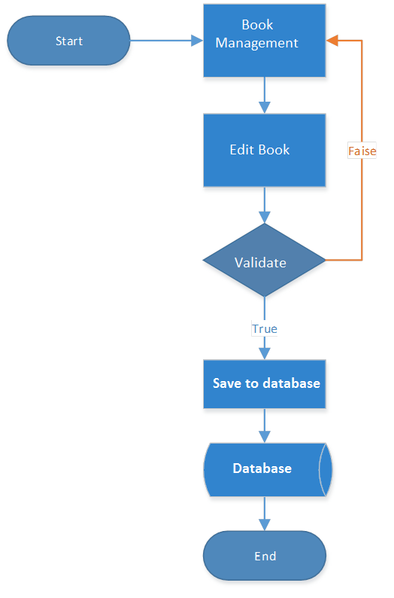

1. **Delete Book (For admin only)**

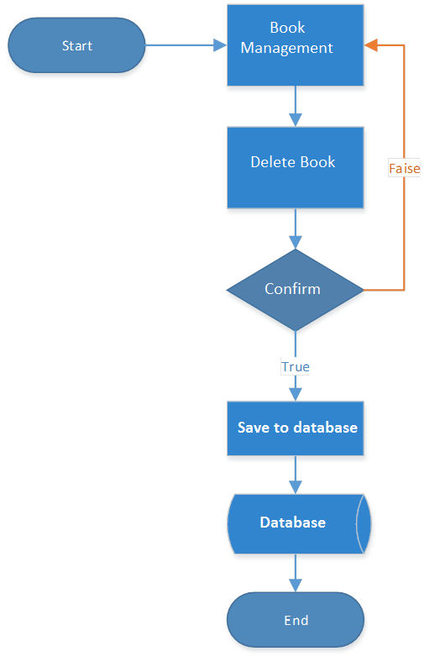

1. **Insert Book (For User only)**

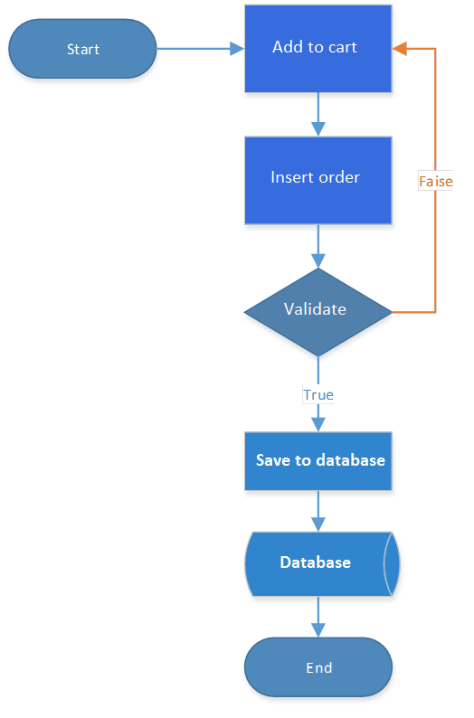

1. **Edit Order (For admin only)**

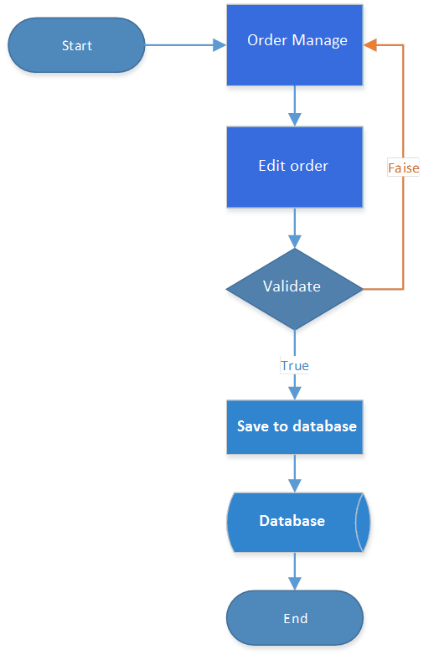

1. **Insert Feedback (For user only)**



**Validate:**  
- Subject: not null, max length: 50  
- Content: not null, max length 500

1. **Delete Feedback (For Admin only)**



1. **Data Flow Diagram (DFD)**

**Define**: Data Flows Diagram (DFD) describes the information flow in the system. The next step of system analysis is to consider in detail the information necessary for the implementation for functions discussed above and the one necessary for the improvement of the functions. Modelling tool frequently used for this purpose is DFD. DFD will support 4 main activities:

**Analysis**: DFD is used to determine requirement of users.

**Design**: DFD is used to map out plan and illustrate solution to analysis and users while designing a new system.

**Communication**: one of the strength of DFD is its simplicity and ease to understand to analysts and users;

**Document**: DFD is used to provide special description of requirement and system design. DFD provide an overview of key functional components of the system but it does not provide any detail on these components. We have to use other tools like database dictionary, process specification to get an idea of which information will be exchanged and how.

The main components of Context Diagram:

|  |  |  |
| --- | --- | --- |
|  | **External** | **The external factors**: External factors can be a person, a group of persons or an organization that are sources of information for the systems and are where system products are transferred to.  **The process**: Shows the common function of system  **The data flow**: Describe the movement of information from one part of the system to another.  **The data store**: The Data Store is used to model a collection of data packets at rest. A store is represented graphically by two parallel lines. The name of a Data Store that identifies the store is the plural of the name of the packets that are carried by flows into and out of the Data Store |
|  | **The process** |
|  | **Data flow** |
|  | **Data store** |

1. **Context Level Diagram**

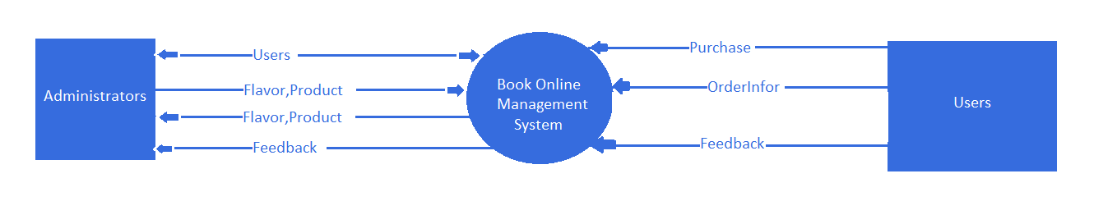

1. **Level 0 DFD**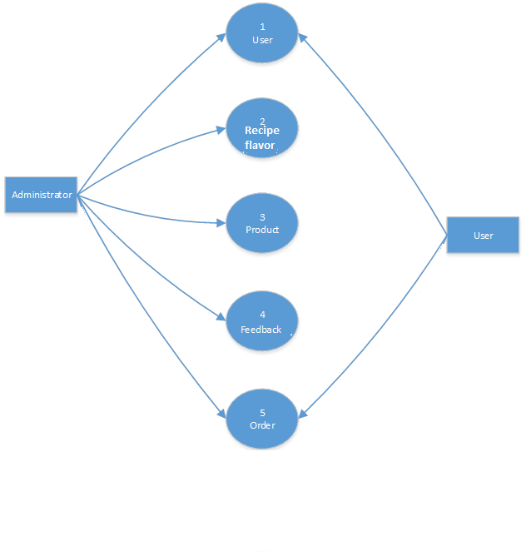
2. **Level 1 DFD**
   1. **Administrators Manage Users**



* 1. **Administrators Manage Product**



* 1. **Administrators Manage Order**



* 1. **Administrators Manage Feedback**



* 1. **User Manage Users**



* 1. **User Manage Order**



* 1. **User Manage Feedback**



1. **Use Case Diagram**

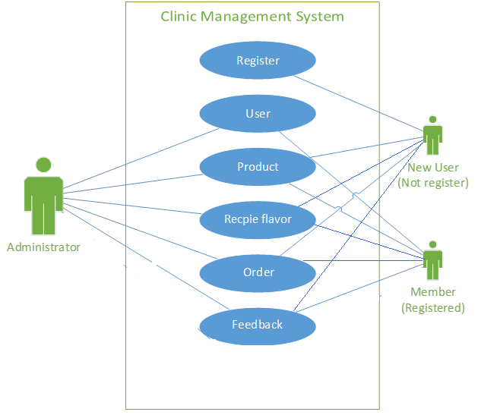

1. **Admin Use Case**

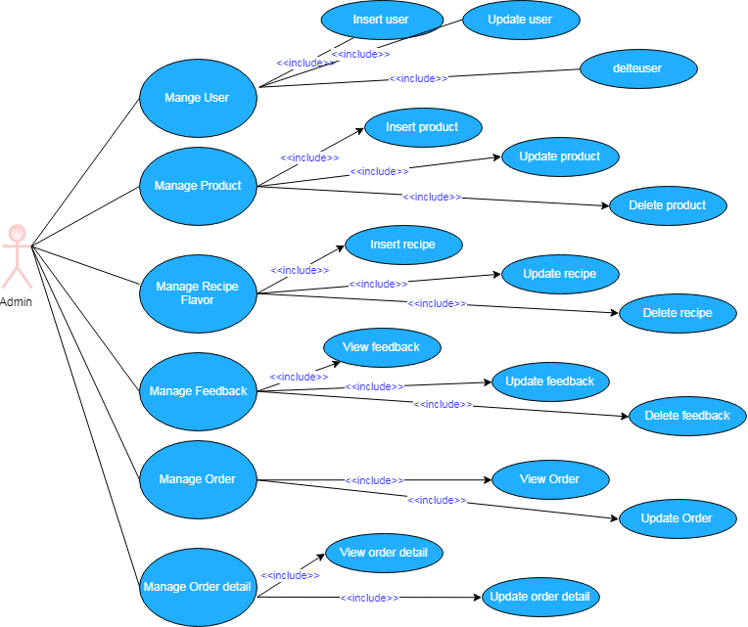

1. **Member Use Case**

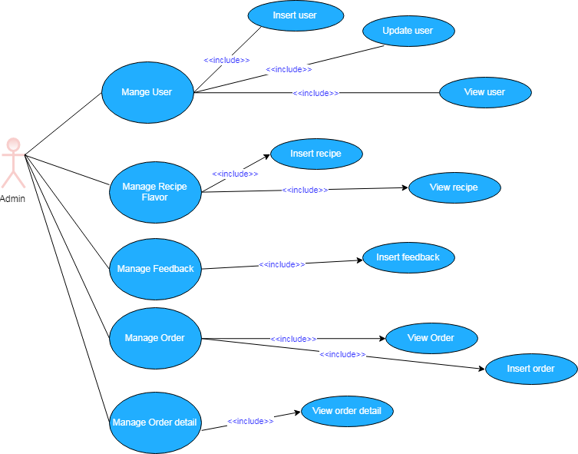

1. **Class Diagram**

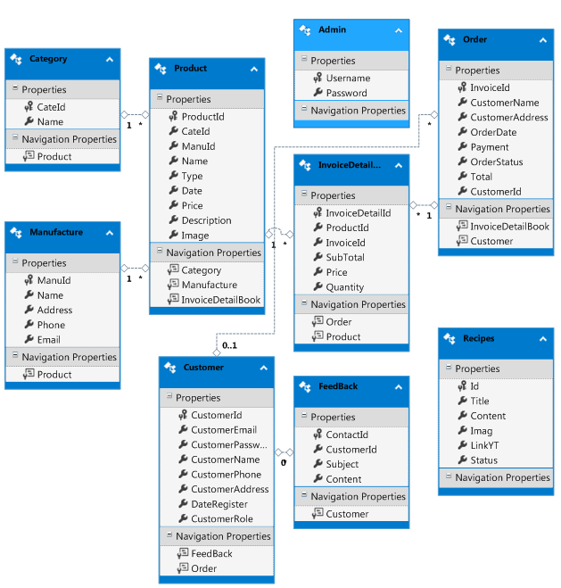

1. **Class Description**
2. **Admin Class**

|  |  |
| --- | --- |
| **Admin Class** | |
| **Attributes** | **Description** |
| **Username** | The code of Admin |
| Password | The code for the Admin can sign in as the system manager |
| **Methods** | **Description** |
| Login | Login to admin can manage website |
| ChangePassword | Alter another password for admin |

1. **User Class**

|  |  |
| --- | --- |
| **User Class** | |
| **Attributes** | **Description** |
| **Username** | The code for the user can sign in as the system manager |
| Password | To be used to user can sign in into the website |
| Fullname | The full name of one user |
| Gender | Identity the gender of user |
| Email | The information about email’s user |
| Address | The information about address’s user |
| Phone | The information about phone’s user |
| DoB | The information about birthday’s user |
| **Methods** | **Description** |
| Insert | Set an new instance of user |
| Update | Recreate account’s user |
| Delete | Remove one user from the system |
| Details | Show all the information above about that user |
| SearchUser | Display users that you want these user to occur |

1. **Order Class**

|  |  |
| --- | --- |
| **Order Class** | |
| **Attributes** | **Description** |
| **InvoiceId** | Code of Order |
| CustomerId | Identify user who wants to buy products |
| OrderDate | Identify day that is ordered |
| Customername | Identify user no account who wants to order products |
| CustommerAddress | Identify address that is ordered |
| Total | Total of product |
| Payment | Identify payment that is ordered |
| OrderStatus | Identify status of order product |
| **Methods** | **Description** |
| Insert | Set a new instance of recipe book |
| Update | Recreate the information’s recipe book |
| Details | Show all the various of flavour recipe book that have in the system |
| SearchProduct | Display the types of medicine that you want these products to occur |

1. **InvoiceDetailBook Class**

|  |  |
| --- | --- |
| **OrderDetails Class** | |
| **Attributes** | **Description** |
| **InvoiceDetailId** | The code of orderdetail |
| InvoiceId | The primary key of InvoiceBook Class that is referenced from InvoiceBook Class |
| Price | Identify price of product |
| Quantity | Identify total quantity of products |
| SubTotal | Subtotal of product |
| ProductId | The code of Product that is referenced from Product Class |
| **Methods** | **Description** |
| Insert | Set an new instance of orderdetail |
| Update | Recreate information of orderdetail |
| Details | Show all the information above about that orderdetails |
| SearchOrderDetails | Display OrderDetails that you want these orderdetails to occur |

1. **Product Class**

|  |  |
| --- | --- |
| **Product Class** | |
| **Attributes** | **Description** |
| **ProductId** | Code of product |
| CateId | Code of category that is referenced from Category Class |
| ManuId | Code of manufacture that is referenced from Manufacture Class |
| Username | Code of user that is referenced from User Class |
| Name | Name of product |
| Type | Type of product |
| Price | Unit price of product |
| Description | The description according to that medicine |
| Image | Image that is demonstrate for that medicine |
| Date | Date of input product |
| **Methods** | **Description** |
| Insert | Set a new instance of medicine |
| Update | Recreate the information’s medicine |
| Delete | Remove one medicine from the system |
| Details | Show all the various of medicine type that have in the system |
| SearchProduct | Display the types of medicine that you want these products to occur |

1. **Feedback Class**

|  |  |
| --- | --- |
| **Feedback Class** | |
| **Attributes** | **Description** |
| **FeedBackId** | The code of feedback class |
| Subject | The subject of feedback class |
| Content | The information is description that feedback |
| CustomerId | The primary key of User Class that is referenced from User Class |
| **Methods** | **Description** |
| Insert | Set a new instance of feedback |
| Delete | Remove one feedback from the system |
| Details | Show all the feedbacks in the system |
| SearchFeedBack | Display the feedbacks that you want to find out |

1. **Entity – Relationship Diagrams**
   * + 1. **Entity – Relationship Diagram Symbols**

|  |  |
| --- | --- |
| Entity | Representing an entity |
| Relationship | Representing a relationship between two entities |
|  | An attribute of entity |
|  | This attribute is primary key |

* + - 1. **Entity – Relationship Diagram**

**Product**

**User**

**Order**

Has

1

n

**Admin**

Create

n

1

n

1

**Feedba**

Has

Has

1

n

**OrderDetails**

n

Has

1

1. **Entities and Properties**
   1. **Customer**

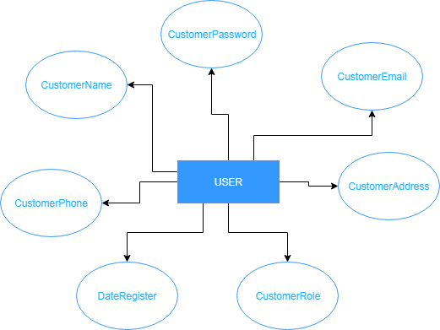

* 1. **Admin**



* 1. **Feedback**



* 1. **Product**



* 1. **Order**

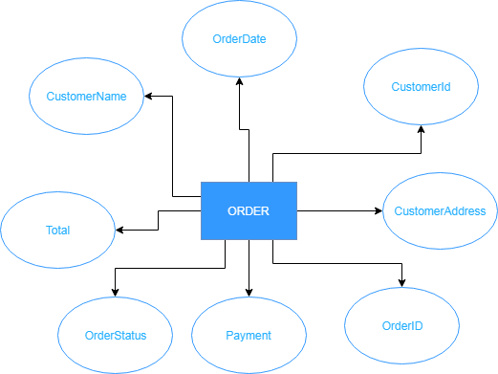

* 1. **InvoiceDetailBook**

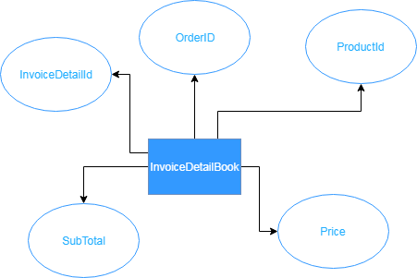

* 1. **Recipes**

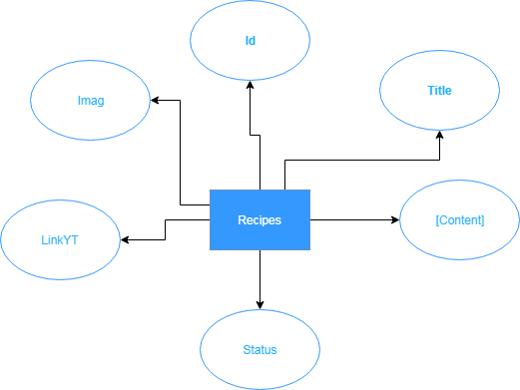

**TASK SHEET REVIEW 2**

|  |  |  |  |  |  |  |  |
| --- | --- | --- | --- | --- | --- | --- | --- |
| **Project Ref. No.:**  **eP/Advertisement** **Portal Management** **System/01** | | **Project Title:** | **Activity Plan** **Prepared** **By:** | **Date of Preparation of Activity Plan:** | | | |
| **Sr.No.** | **Task** | **Actual Start** **Date** | **Actual** **Days** | **Team** **Mate** **Names** | **Status** |
| 1 | Architecture & Design of Project | Ice Cream Shop Management  System | Phong | 14/7/2019 | 2 | All Member | Completed |
| 2 | Algorithms – Data Flowchart | 14/7/2019 | 3 | All Member | Completed |
| 3 | Data Flow Diagram | 14/7/2019 | 3 | Tien | Completed |
| 4 | Use Case Diagram | 14/7/2019 | 3 | Dat | Completed |
| 5 | Class Diagram | 14/7/2019 | 3 | Tien | Completed |
| 6 | Class Description | 14/7/2019 | 3 | Phong | Completed |
| 7 | Entity-Relationship Diagram | 14/7/2019 | 3 | Phong | Completed |
| 8 | Task sheet review | 14/7/2019 | 3 | Phong | Completed |

|  |  |
| --- | --- |
| **Date: 20/07/2019** | |
| Signature of Instructor:  **Ms. Le Mong Thuy** | Signature of Team Leader:  **Chau Thanh Phong** |

# REVIEW 3

1. **DATABASE DESIGN**
2. **Database Design Diagram**

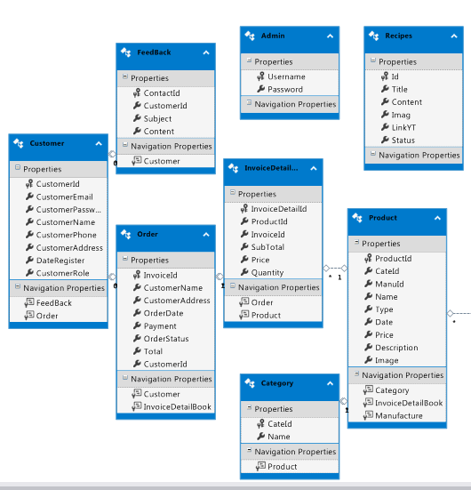

1. **Database Structure**
   1. **Table Admin**

|  |  |  |  |  |  |  |  |
| --- | --- | --- | --- | --- | --- | --- | --- |
| **No** | **Field Name** | **Data Type** | **Null** | **Default** | **Key** | **Reference Table** | **Description** |
| 1 | Username | varchar(20) | No | **admin** | PK |  | Admin’s Username |
| 2 | Password | varchar(20) | No | **123456** |  |  | Admin’s Password |

* 1. **Table Customer**

|  |  |  |  |  |  |  |  |
| --- | --- | --- | --- | --- | --- | --- | --- |
| **No** | **Field Name** | **Data Type** | **Null** | **Default** | **Key** | **Reference Table** | **Description** |
| 1 | CustomerId | int | No | Identity(1,1) | **PK** |  | User’s ID |
| 2 | CustomerPassword | varchar(50) | Yes |  |  |  | User’s Password |
| 3 | CustomerName | varchar(50) | Yes |  |  |  | User’s Name |
| 4 | CustomerPhone | varchar(100) | Yes |  |  |  | User’s Phone |
| 5 | CustomerAddress | datetime | Yes |  |  |  | User’s Address |
| 6 | DateRegister | varchar(50) | Yes |  |  |  | User’s Date Regist |
| 7 | CustomerRole | tinyint | Yes |  |  |  | User’s Role |
| 8 | CustomerEmail | varchar(50) | Yes |  |  |  | User’s Email |

|  |  |  |  |  |  |  |  |
| --- | --- | --- | --- | --- | --- | --- | --- |
| **No** | **Field Name** | **Data Type** | **Null** | **Default** | **Key** | **Reference Table** | **Description** |
| 1 | ContactId | int | No | Identity(1,1) | PK |  | Feedback’s ID |
| 2 | CustomerId | Int | No |  | **FK** | User(ID) | User’s ID |
| 3 | Subject | varchar(500) | No |  |  |  | Feedback’s Subject |
| 4 | [Content] | varchar(30) | No |  |  |  | Feedback’s Content |

* 1. **Table Feedback**
  2. **Table Category**

|  |  |  |  |  |  |  |  |
| --- | --- | --- | --- | --- | --- | --- | --- |
| **No** | **Field Name** | **Data Type** | **Null** | **Default** | **Key** | **Reference Table** | **Description** |
| 1 | CateId | Int | No | Identity(1,1) | PK |  | Category’s ID |
| 2 | Name | varchar(50) | No |  |  |  | Category’s Name |

* 1. **Table Product**

|  |  |  |  |  |  |  |  |
| --- | --- | --- | --- | --- | --- | --- | --- |
| **No** | **Field Name** | **Data Type** | **Null** | **Default** | **Key** | **Reference Table** | **Description** |
| 1 | ProductId | int | No | Identity(1,1) | PK |  | Product’s ID |
| 2 | CateId | int | No |  | FK | Category (CateId) | Category’s ID |
| 3 | ManuId | int | No |  | FK | Manufacture (ManuId) | Manufacture’s ID |
| 4 | Name | varchar(50) | No |  |  |  | Product’s Name |
| 5 | Type | varchar(50) | No |  |  |  | Product’s Type |
| 6 | Date | datetime | No |  |  |  | Recipe Date |
| 7 | Price | double | No |  |  |  | Product’s Price |
| 8 | Description | varchar(1000) | No |  |  |  | Product’s Description |
| 9 | Image | varchar(50) | No |  |  |  | Product’s Image |

* 1. **Table Recipes**

|  |  |  |  |  |  |  |  |
| --- | --- | --- | --- | --- | --- | --- | --- |
| **No** | **Field Name** | **Data Type** | **Null** | **Default** | **Key** | **Reference Table** | **Description** |
| 1 | Id | int | No | identity(1,1) | PK |  | Recipe’s ID |
| 2 | Title | varchar(100) | Yes |  |  |  | Recipe’s Ttile |
| 3 | [Content] | text | Yes |  |  |  | Recipe’s Content |
| 4 | Imag | text | Yes |  |  |  | Recipe’s Image |
| 5 | LinkYT | text | Yes |  |  |  | Recipe’s Link |
| 6 | Status | varchar(10) | Yes |  |  |  | Recipe’s Status |

* 1. **Table Order**

|  |  |  |  |  |  |  |  |
| --- | --- | --- | --- | --- | --- | --- | --- |
| **No** | **Field Name** | **Data Type** | **Null** | **Default** | **Key** | **Reference Table** | **Description** |
| 1 | InvoiceId | int | No | Identity(1,1) | PK |  | Order’s ID |
| 2 | CustomerId | int | No |  | FK | Customer(CustomerId) | Customer’s ID |
| 3 | CustomerName | varchar(50) | No |  |  |  | Order’s Customer Name |
| 4 | CustomerAddress | varchar(50) | No |  |  |  | Order’s Customer Address |
| 5 | OrderDate | datetime | No |  |  |  | Order Date |
| 6 | Payment | varchar(20) | No |  |  |  | Payment |
| 7 | OrderStatus | bit | No |  |  |  | Order Status |
| 8 | Total | int | No |  |  |  | Total |

* 1. **Table InvoiceDetailBook**

|  |  |  |  |  |  |  |  |
| --- | --- | --- | --- | --- | --- | --- | --- |
| **No** | **Field Name** | **Data Type** | **Null** | **Default** | **Key** | **Reference Table** | **Description** |
| 1 | InvoiceDetailId | int | No | identity(1,1) | PK |  | OrderDetails’s ID |
| 2 | InvoiceId | int | No |  | FK | Order (OrderId) | Order’s ID |
| 3 | ProductId | int | No |  | FK | Product (ProductId) | Product’s ID |
| 4 | Price | double | No |  |  |  | Product’s Price |
| 5 | Quantity | int | No |  |  |  | Product’s Quantity |
| 6 | SubTotal | double | No |  |  |  | Product’s Sub Total |

1. **GUI DESIGN**
2. **User Interface**
   1. **Home Page:** Introduce the website with the navigation bar links.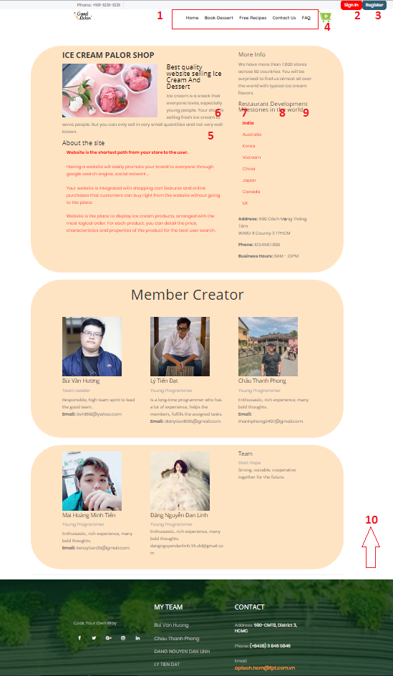

|  |  |  |  |  |  |  |
| --- | --- | --- | --- | --- | --- | --- |
| **No** | **Name** | **Type** | **Source Code** | **Event** | **Description** | **Status** |
| 1 | Navigation Bar | Hyperlink | Figure 1 | Click | Choose & click to go to sub pages | Enable |
| 2 | Login | Hyperlink | Click | Click to go to login page | Enable |
| 3 | Register | Hyperlink | Click | Click to go to register page | Enable |
| 4 | Cart | Hyperlink | Click | Click to go to cart page | Enable |
| 5 | Form About Us | TextBox | Figure 2 | Focus | Information about website | Enable |
| 6 | Book Dessert | Hyperlink | Figure 1 | Click | Click to go to Book product page | Enable |
| 7 | Free Recipes | Hyperlink | Click | Click to go to Recipes page(login to see Full Recipes) | Enable |
| 8 | FAQ | Hyperlink | Click | Frequently asked questions | Enable |
| 9 | Conatct | Hyperlink | Figure 1 | Click | Send feedback | Enable |
| 10 | Footer | Hyperlink | Figure 3 | Click | Some information to contact with clinic | Enable |

* 1. **Contact Us Page:** Show contact information of clinic & feedback form for user. (must login first to send feedback)

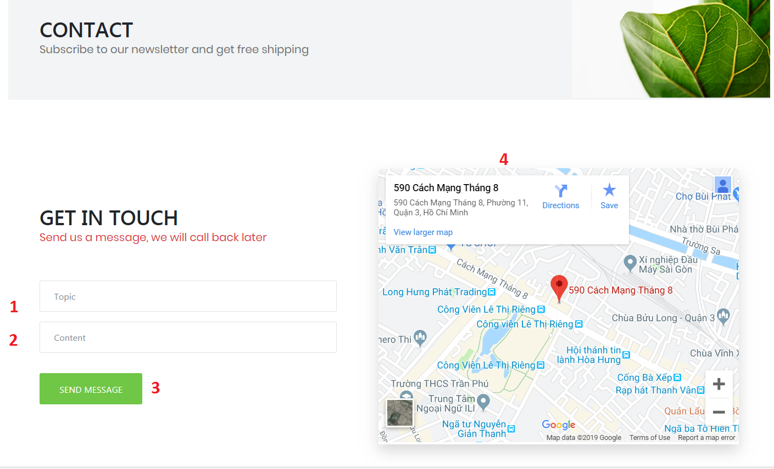

|  |  |  |  |  |  |  |
| --- | --- | --- | --- | --- | --- | --- |
| **No** | **Name** | **Type** | **Validation** | **Event** | **Description** | **Status** |
| 1 | Subject | Textbox | - Not null - Max length:50 | Focus | Input feedback’s subject | Enable |
| 2 | Message | Textbox | - Not null - Max length:500 | Focus | Input feedback’s content | Enable |
| 3 | Send Message | Button |  | Click | Click to send feedback | Enable |
| 4 | Map |  |  |  | Location of My Store | Enable |

If send feedback successfully, a notification will appear, click to go back contact page:

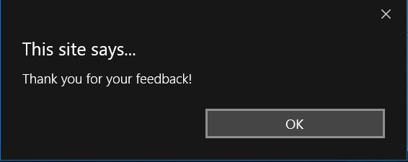

* 1. **Login Page:** Login form for user

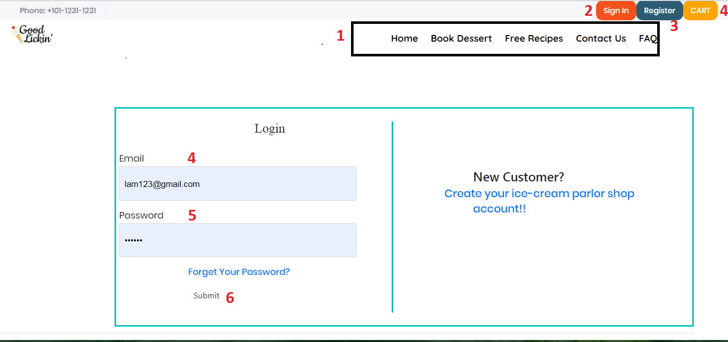

|  |  |  |  |  |  |  |
| --- | --- | --- | --- | --- | --- | --- |
| **No** | **Name** | **Type** | **Validation** | **Event** | **Description** | **Status** |
| 1 | Navigation Bar | Hyperlink |  | Click | Choose & click to go to sub pages | Enable |
| 2 | Login | Hyperlink |  | Click | Click to go to login page | Enable |
| 3 | Register | Hyperlink |  | Click | Click to go to register page | Enable |
| 4 | Cart | Hyperlink |  | Click | Click to go to cart page (must be login first) | Enable |
| 5 | Email | Textbox | - Not null - Min lengh:5 - Max length:20 | Focus | Input Email | Enable |
| 6 | Password | Password | - Not null - Min lengh:6 - Max length:20 | Focus | Input password | Enable |
| 7 | Login | Button |  | Click | Click to login | Enable |

* 1. **Logout:** notification will appear when admin click logout button

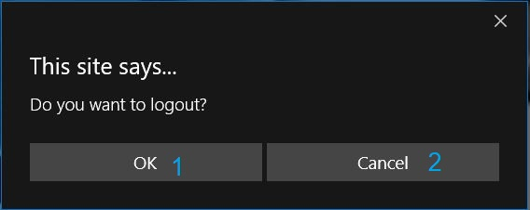

|  |  |  |  |  |  |  |
| --- | --- | --- | --- | --- | --- | --- |
| **No** | **Name** | **Type** | **Validation** | **Event** | **Description** | **Status** |
| 1 | btnOk | Button |  | Click | Click to logout | Enable |
| 2 | btnCancel | Button |  | Click | Click to return | Enable |

* 1. **Register Page:** Register form for user if they haven’t account.

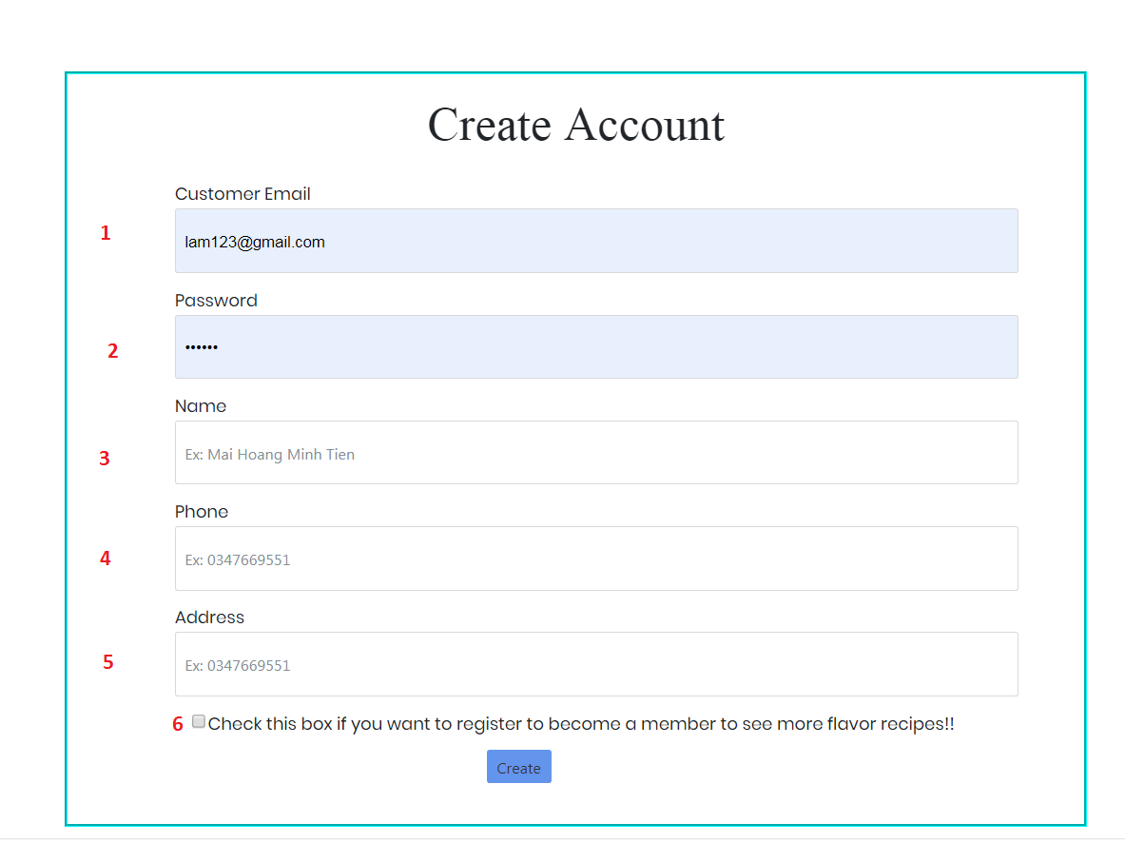

|  |  |  |  |  |  |  |
| --- | --- | --- | --- | --- | --- | --- |
| **No** | **Name** | **Type** | **Validation** | **Event** | **Description** | **Status** |
| 1 | CustomerEmail | Textbox | - Not null - Min lengh:5 - Max length:20 | Focus | Show your Email | Enable |
| 2 | Password | Password | - Not null - Min lengh:6 - Max length:20 | Focus | Input password | Enable |
| 3 | Name | Textbox | - Not null - Max length:50 | Focus | Input name | Enable |
| 4 | Phone Number | Textbox | - Not null - Max length:15 | Focus | Input phone number | Enable |
| 5 | Address | Textbox | - Not null - Max length:50 | Focus | Input address | Enable |
| 6 | CheckBox | Radio |  | Focus | Check value member if user want | Enable |

* 1. **Change Personal Information Page:** User can change their information here.

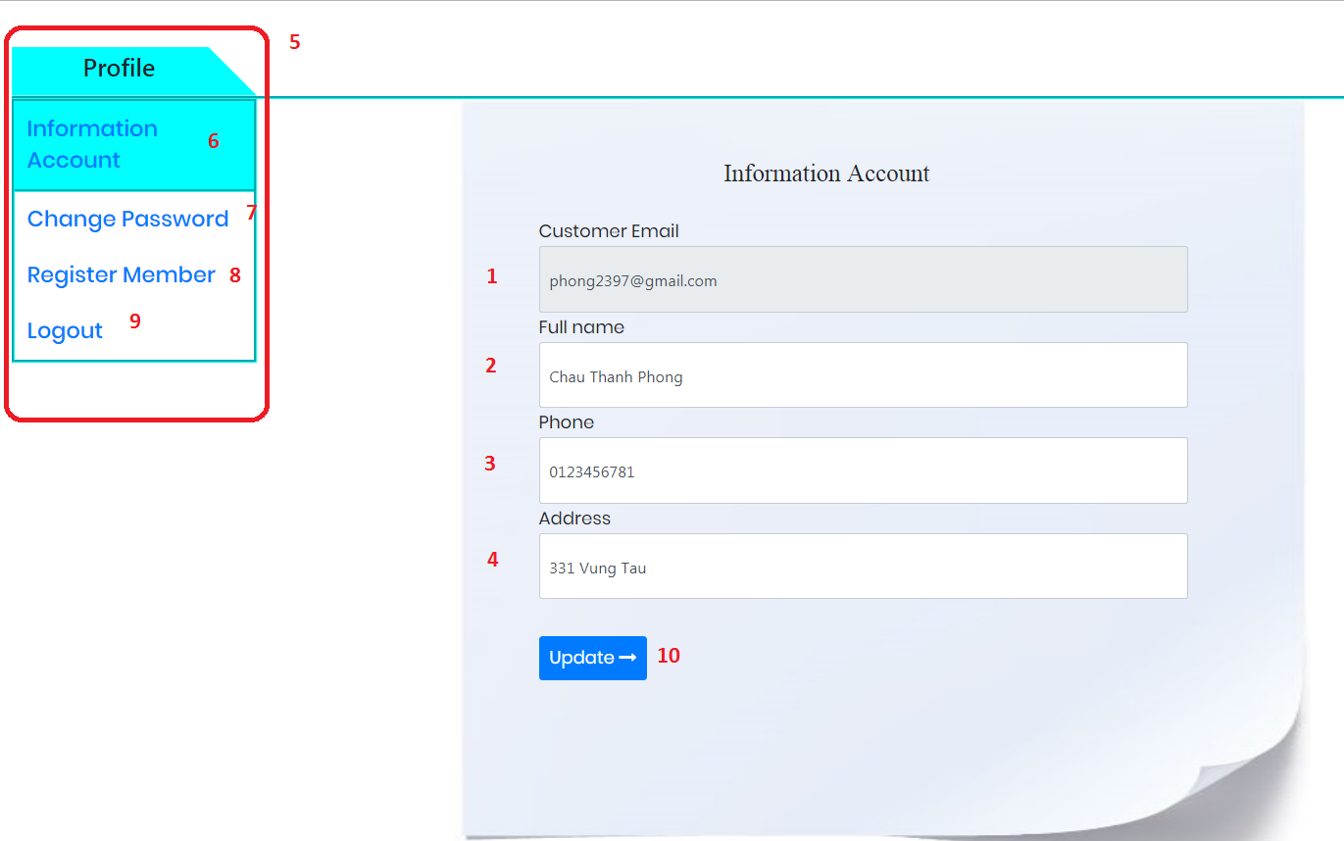

|  |  |  |  |  |  |  |
| --- | --- | --- | --- | --- | --- | --- |
| **No** | **Name** | **Type** | **Validation** | **Event** | **Description** | **Status** |
| 1 | Customer Email | Textbox (Read only) |  | Focus | Email | Disable |
| 2 | Full name | Textbox | - Not null - Max length:50 | Focus | Input to change full name | Enable |
| 3 | Phone Number | Textbox | - Not null - Max length:15 | Focus | Input to change phone number | Enable |
| 4 | Address | Textbox | - Not null - Max length:50 | Focus | Input to change address | Enable |
| 5 | Profile | Textbox |  | Focus | Tab to change page | Enable |
| 6 | Information Account | Hyperlink |  | Click | Go to Profile page(must be login) | Enable |
| 7 | Register Member | Hyperlink |  | Click | Go to Register page (must be login) | Enable |
| 8 | Change Password | Hyperlink |  | Click | Go to Change Password Page | Enable |
| 9 | Logout | Hyperlink |  | Click | Sign out the page | Enable |
| 10 | Update | Button |  | Click | Click to update information | Enable |

* 1. **Update Password Page:** User can change their Password here.

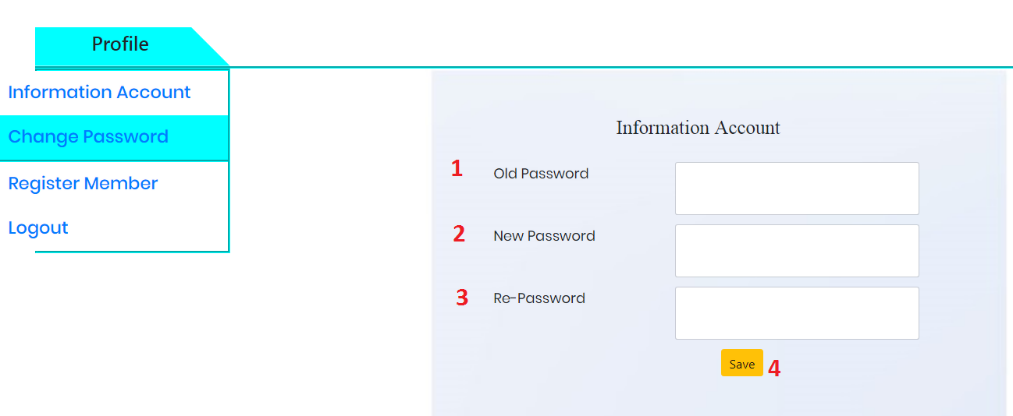

|  |  |  |  |  |  |  |
| --- | --- | --- | --- | --- | --- | --- |
| **No** | **Name** | **Type** | **Validation** | **Event** | **Description** | **Status** |
| 1 | Old Password | Old Password | - Not null - Min lengh:6 - Max length:20 | Focus | Input the old password | Enable |
| 2 | New Password | New Password | - Not null - Min lengh:6 - Max length:20 | Focus | Input the new password | Enable |
|  | RePassword | Re Password | Not null - Max length:50 | Focus | reinput the new password | Enable |
| 3 | Save | Button | - | Click | Click to update information | Enable |

* 1. **Register Member Page:**If the user is not register ,user can fill value member is this profiles.

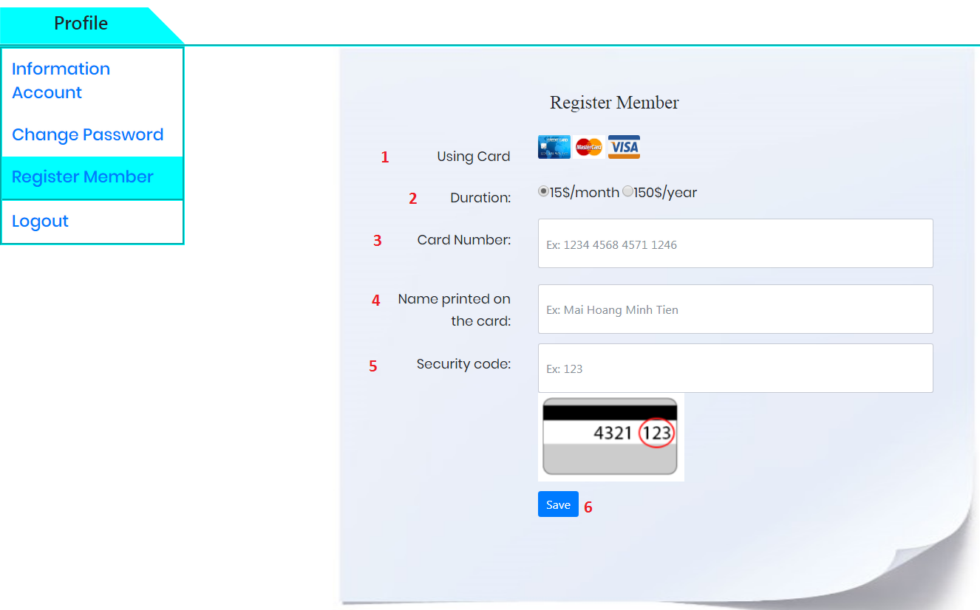

|  |  |  |  |  |  |  |  |
| --- | --- | --- | --- | --- | --- | --- | --- |
| **No** | **Name** | **Type** | **Validation** | | **Event** | **Description** | **Status** |
| 1 | Using Card | img | |  | Focus |  | Enable |
| 2 | Duration | Radio Btn | |  | Focus | Choose member price | Enable |
| 3 | Name Printed on the card | Textbox | |  | Focus | Input Full Name | Enable |
| 4 | Name Printed on the card | TextBox | |  | Focus | Input Name On Card | Enable |
| 5 | Security Code | Textbox | |  | Focus | Input the number | Enable |

* 1. **Book Page:** This page display list of medicines, user can search item with search bar.

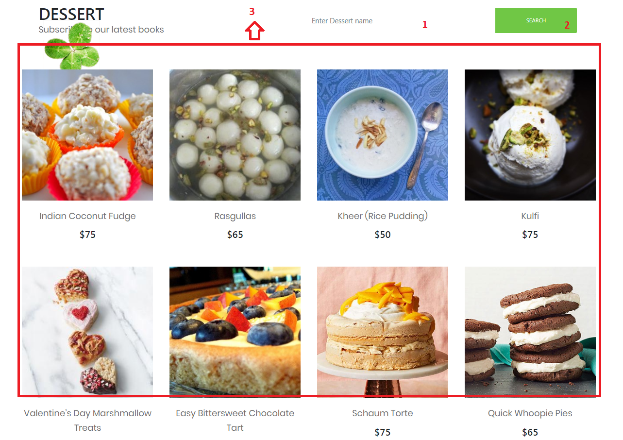

|  |  |  |  |  |  |  |
| --- | --- | --- | --- | --- | --- | --- |
| **No** | **Name** | **Type** | **Validation** | **Event** | **Description** | **Status** |
| 1 | txtSearch | Textbox |  | Focus | Input medicine name to search | Enable |
| 2 | btnSearch | Button |  | Click | Click to search Book | Enable |
| 3 | btnAdd to Cart | Button |  | Click | Click to search medicine | Enable |

* 1. **Product Details Page:** This page display information of a product. User

also can add this product to cart

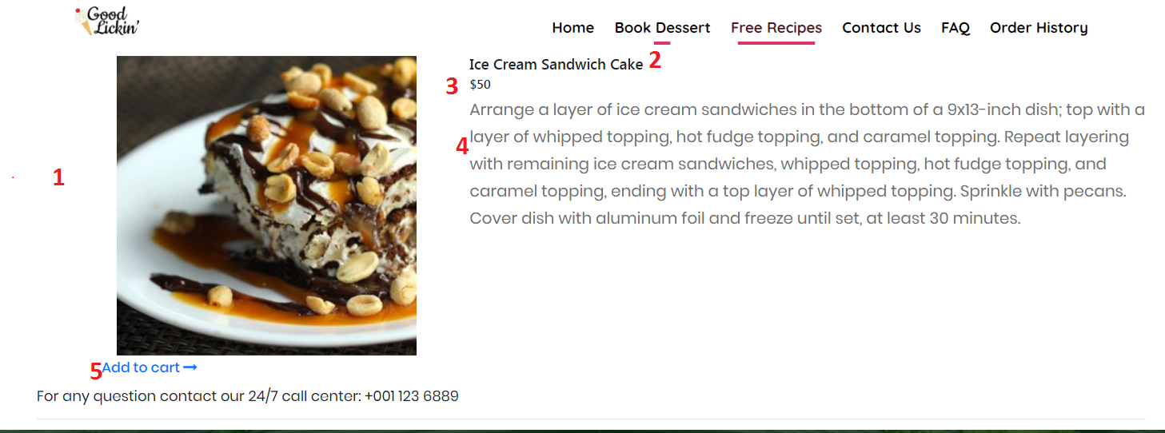

|  |  |  |  |  |  |  |
| --- | --- | --- | --- | --- | --- | --- |
| **No** | **Name** | **Type** | **Validation** | **Event** | **Description** | **Status** |
| 1 | Image | Image |  |  | Product’s image | Enable |
| 2 | Name | Textbox (Read only) |  |  | Product’s name | Enable |
| 3 | Price | Textbox (Read only) |  |  | Product’s price | Enable |
| 4 | Description | Textbox (Read only) |  |  | Product’s description | Enable |
| 5 | Add to Cart | Button |  | Click | Click to add product to your cart (must be login first) | Enable |

* 1. **Free Recipes:** This page display list of recipes for your user don’t use account.

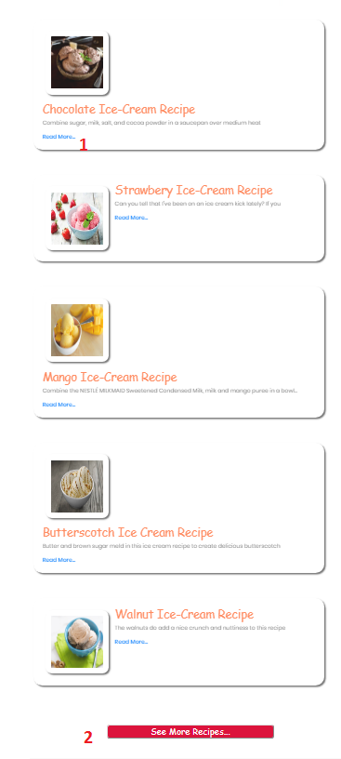

|  |  |  |  |  |  |  |
| --- | --- | --- | --- | --- | --- | --- |
| **No** | **Name** | **Type** | **Validation** | **Event** | **Description** | **Status** |
| 1 | Read | Button |  | Click | Go to the video detail of recipes | Enable |
| 2 | See More Recipe | Button |  | Click | Click to Full Recipes(must be login) | Enable |

* 1. **Full Recipes:** This page display list of recipes for your user register a member as month or year

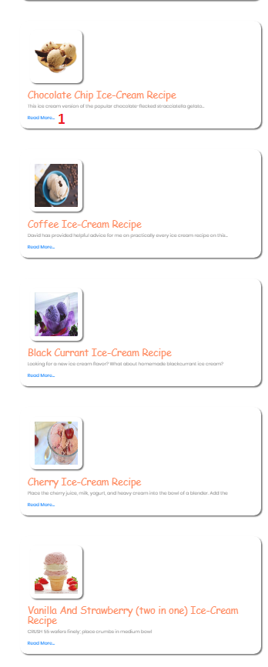

|  |  |  |  |  |  |  |
| --- | --- | --- | --- | --- | --- | --- |
| **No** | **Name** | **Type** | **Validation** | **Event** | **Description** | **Status** |
| 1 | Read | Button |  | Click | Go to the video detail of recipes | Enable |

* 1. **Detail of Recipes:** This page display the way to cook this favourite ice cream.

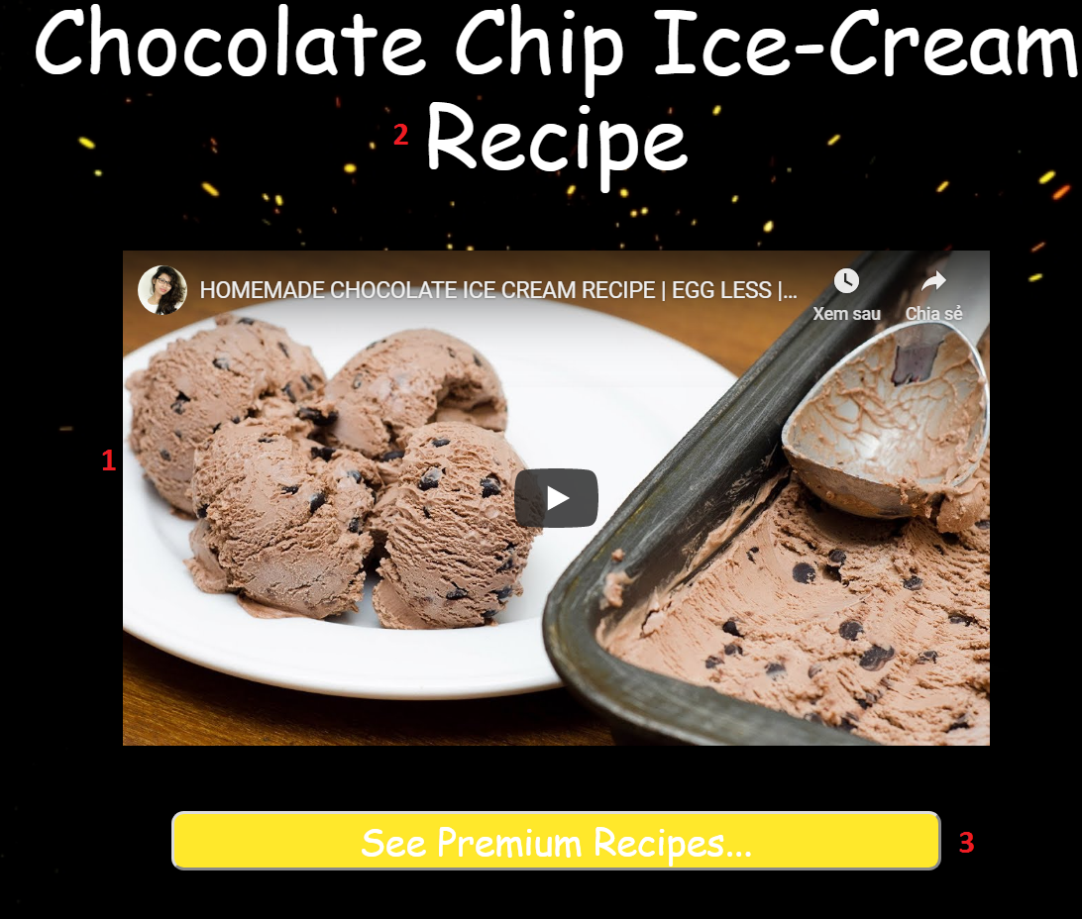

|  |  |  |  |  |  |  |
| --- | --- | --- | --- | --- | --- | --- |
| **No** | **Name** | **Type** | **Validation** | **Event** | **Description** | **Status** |
| 1 | Video | Linkyt |  |  | Product’s Video | Enable |
| 2 | Name | Textbox (Read only) |  |  | Recipes’s name | Enable |
| 3 | btnRecipes | Button | Login before see full recipes |  | Click go to the full recipes page (must be login first) | Enable |

* 1. **FAQ Page:** This page display list of frequently of question.

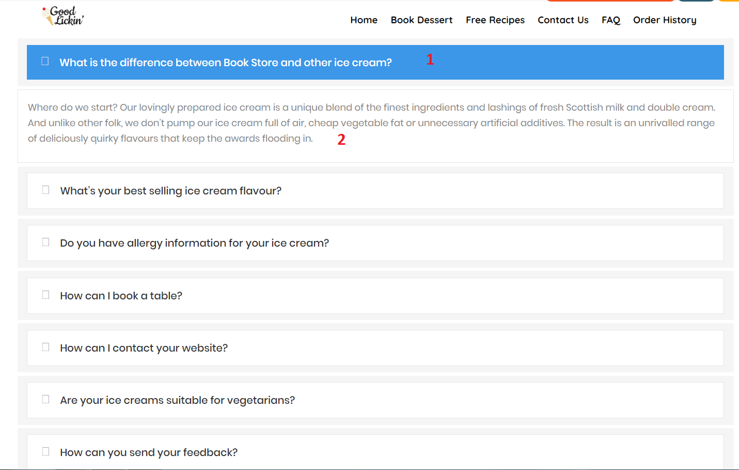

|  |  |  |  |  |  |  |
| --- | --- | --- | --- | --- | --- | --- |
| **No** | **Name** | **Type** | **Validation** | **Event** | **Description** | **Status** |
| 1 | PanelTitle | Textbox |  | Focus | Question’s Customer | Enable |
| 2 | PanelBody | Textbox |  | Focus | Anser from my website | Enable |

* 1. **Your Cart Page:** Items which user had chosen will display here.

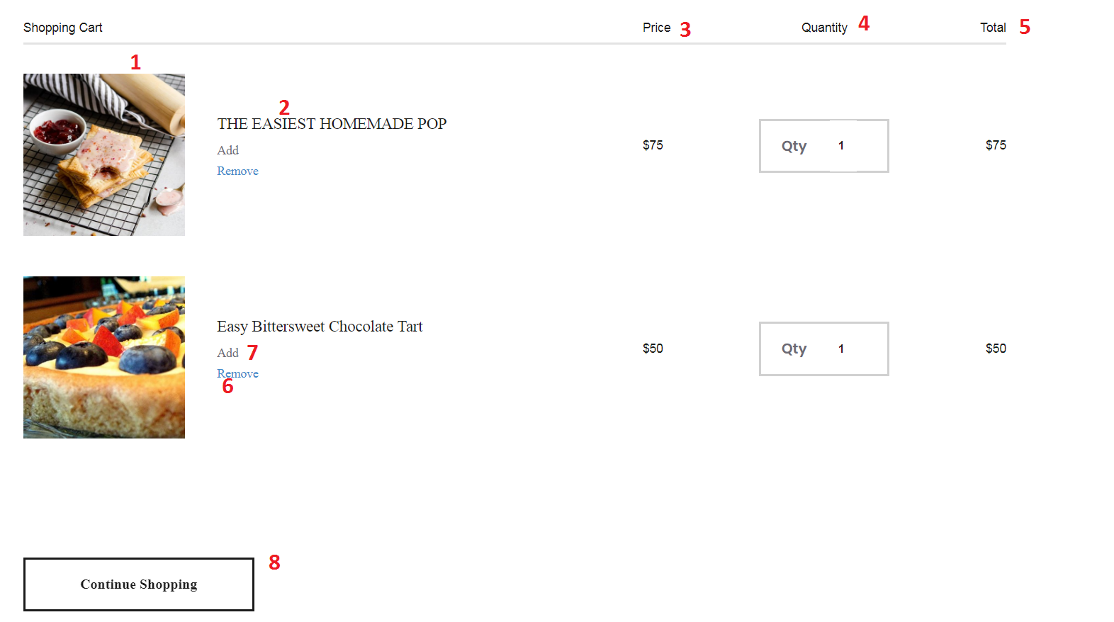

|  |  |  |  |  |  |  |
| --- | --- | --- | --- | --- | --- | --- |
| **No** | **Name** | **Type** | **Validation** | **Event** | **Description** | **Status** |
| 1 | Image | Image |  |  | Product’s image | Enable |
| 2 | Name | Textbox (Read only) |  |  | Product’s name | Enable |
| 3 | Price | Textbox (Read only) |  |  | Product’s unit price | Enable |
| 4 | Quantity | Textbox |  | Focus | Product’s quantity, if user want update quantity, type number of product want to buy and then press enter, the cart will reload & update | Enable |
| 5 | Subtotal | Textbox (Read only) |  |  | Product’s subtotal price | Enable |
| 6 | Remove | Button |  | Click | Click to clear cart | Enable |
| 7 | Add | Button |  | Click | Click to update quantity | Enable |
| 8 | Continue shopping | Button |  | Click | Click to go back home page | Enable |

* 1. **Checkout page:** This page show for user confirm payment.

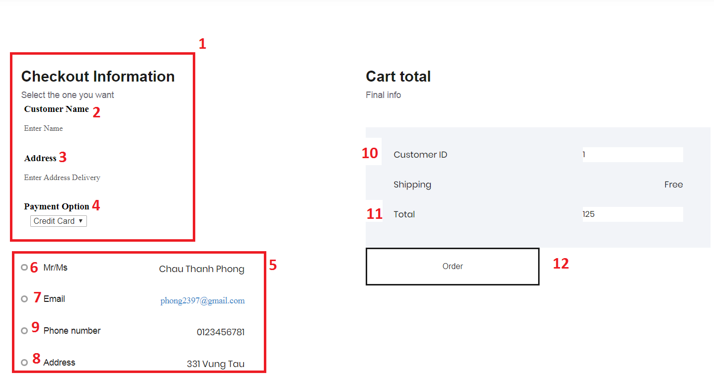

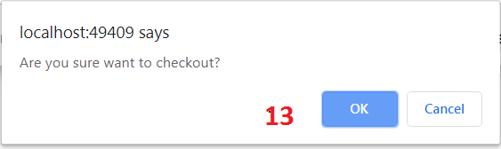

|  |  |  |  |  |  |  |
| --- | --- | --- | --- | --- | --- | --- |
| **No** | **Name** | **Type** | **Validation** | **Event** | **Description** | **Status** |
| 1 | User’Order | Textbox |  |  | Form Order | Enable |
| 2 | Customer name | Textbox | Not null  Max length :30 |  | User input into the name  (both user register and no register) | Enable |
| 3 | Address | Textbox | Not null  Max length :30 |  | User input into the Address  (both user register and no register) | Enable |
| 4 | Payment option | Select | Not null |  | User choose your payment to order(both user register and no register) | Enable |
| 5 | Inforamtion user | Textbox (Read only) |  |  | User’s information(must be login) | Enable |
| 6 | User Name | Textbox (Read only) |  |  | User’s Name | Enable |
| 7 | Email | Textbox (Read only) |  |  | User’s Email | Enable |
| 8 | Address | Textbox (Read only) |  |  | User’s Address | Enable |
| 9 | Phone Number | Textbox (Read only) |  |  | User’s Phone | Enable |
| 10 | CustomerID | TextBox(Read only) |  | Focus | Primary key of Customer | Enable |
| 11 | Total | TextBox(read only) |  | Focus | Sum of quantity and price of product | Enable |
| 12 | Order | Button |  | Click | Click to checkout order | Enable |
| 13 | Ok | Button |  | Click | Click to confirm checkout | Enable |

* 1. **InvoiceDetailBook:** this page display information about order user just bought

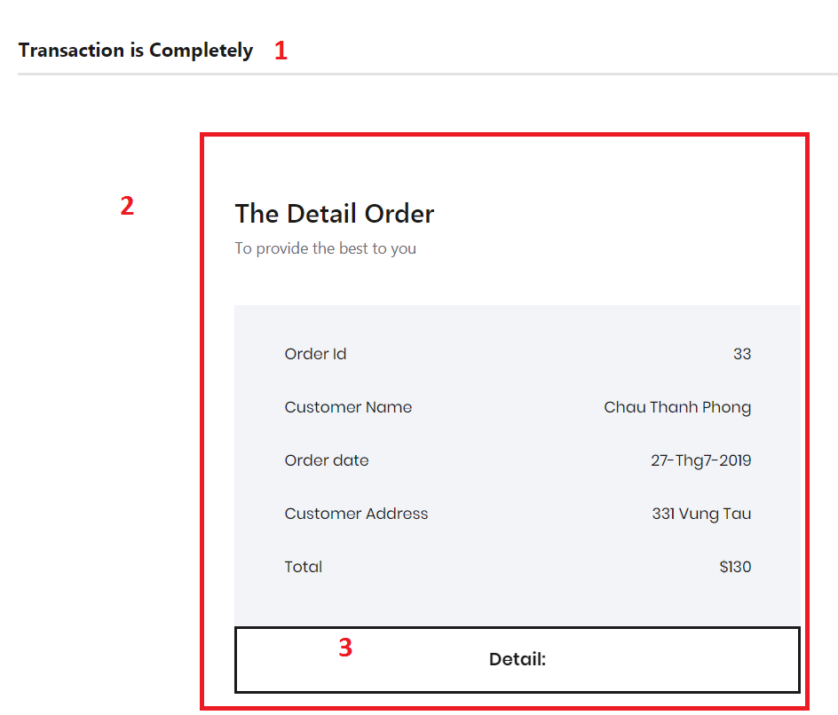

|  |  |  |  |  |  |  |
| --- | --- | --- | --- | --- | --- | --- |
| **No** | **Name** | **Type** | **Validation** | **Event** | **Description** | **Status** |
| 1 | Result | Textbox (Read only) |  |  | Message to customer order complete | Enable |
| 2 | Order information | Textbox (Read only) |  |  | Order information | Enable |
| 3 | Details | Button |  |  | Click to view details of this order | Enable |

* 1. **Details of an order:** when user click details button in order details page, it will show details of it.

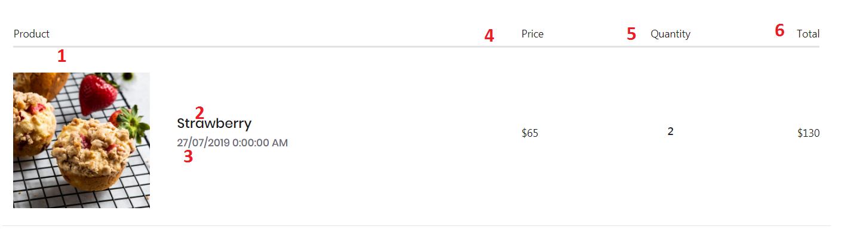

|  |  |  |  |  |  |  |
| --- | --- | --- | --- | --- | --- | --- |
| **No** | **Name** | **Type** | **Validation** | **Event** | **Description** | **Status** |
| 1 | Image | Textbox (Read only) |  |  | Product’s image | Enable |
| 2 | Product Name | Textbox (Read only) |  |  | Product’s name | Enable |
| 3 | Order Date | Textbox (Read only) |  |  | Order date | Enable |
| 4 | Unit price | Textbox (Read only) |  |  | Product’s unit price | Enable |
| 5 | Quantity | Textbox (Read only) |  |  | Quantity | Enable |
| 6 | Subtotal | Textbox (Read only) |  |  | Product’s subtotal | Enable |

* 1. **Personal order history:** this page display history all orders of personal user. User can view it by click to menu “Order History” appears when user login successfully.



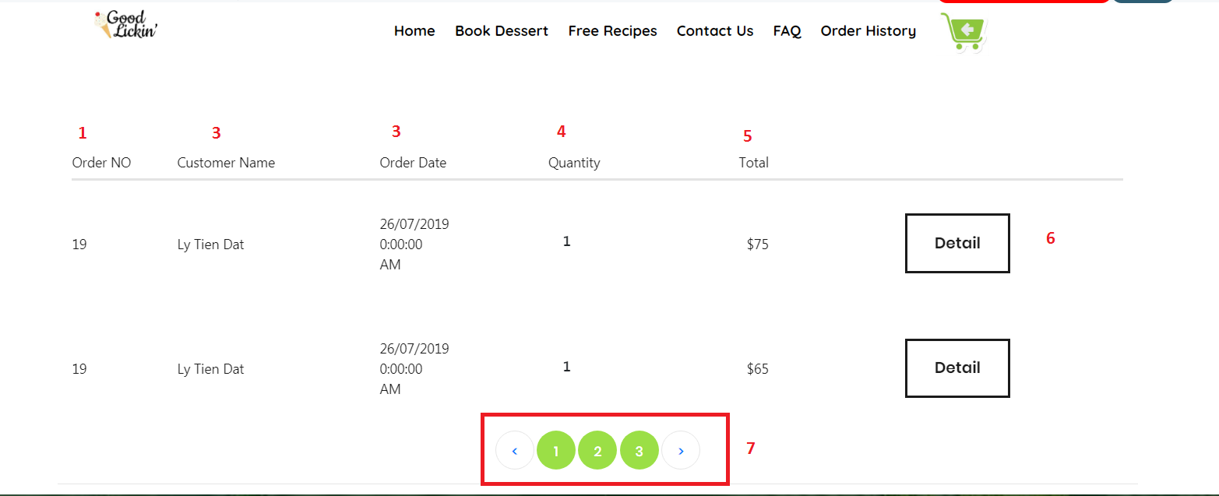

|  |  |  |  |  |  |  |
| --- | --- | --- | --- | --- | --- | --- |
| **No** | **Name** | **Type** | **Validation** | **Event** | **Description** | **Status** |
| 1 | OrderId | Textbox (Read only) |  |  | Id of Order | Enable |
| 2 | Customer Name | Textbox (Read only) |  |  | Customer’s Name | Enable |
| 3 | Order Date | Textbox (Read only) |  |  | Order date | Enable |
| 4 | Quantity | Textbox (Read only) |  |  | Quantity | Enable |
| 5 | Subtotal | Textbox (Read only) |  |  | Product’s subtotal | Enable |
| 6 | btnDetail | Button |  | Click | Details of Order | Enable |
| 7 | Number Page | Hyperlink |  | Click | Number Page Order history |  |

1. **Admin Interface:**
   1. **Login Page**: Login form for admin (default: Username: **admin**, password: **123456**)

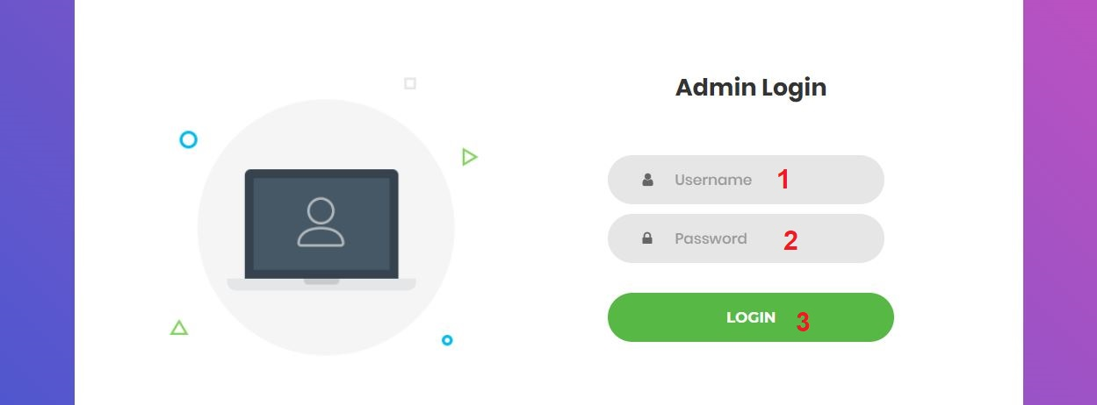

|  |  |  |  |  |  |  |
| --- | --- | --- | --- | --- | --- | --- |
| **No** | **Name** | **Type** | **Validation** | **Event** | **Description** | **Status** |
| 1 | txtUsername | Textbox | -Not null  -Min length:5  -Max length:20 | Focus | Input username | Enable |
| 2 | txtPassword | Textbox (password) | -Not null  -Min length:6  -Max length:20 | Focus | Input password | Enable |
| 3 | btnSubmit | Button |  | Click | Click to login | Enable |

* 1. **Logout:** notification will appear when admin click logout button



|  |  |  |  |  |  |  |
| --- | --- | --- | --- | --- | --- | --- |
| **No** | **Name** | **Type** | **Validation** | **Event** | **Description** | **Status** |
| 1 | btnOk | Button |  | Click | Click to logout | Enable |
| 2 | btnCancel | Button |  | Click | Click to return | Enable |

* 1. **Change Password Page:** Admin can change password here

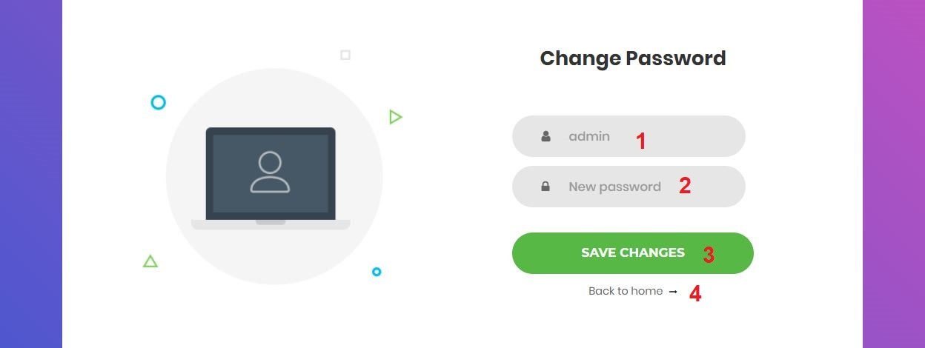

|  |  |  |  |  |  |  |
| --- | --- | --- | --- | --- | --- | --- |
| **No** | **Name** | **Type** | **Validation** | **Event** | **Description** | **Status** |
| 1 | Username | Textbox (Read only) |  | Focus | Username |  |
| 2 | New Password | Textbox (password) | - Not null  - Min length:6  - Max length:20 | Focus | Input new password | Enable |
| 3 | Save changes | Button |  | Click | Click to change password | Enable |
| 4 | Back to Home | Hyperlink |  | Click | Click to return home page | Enable |

* 1. **Home Page:** has navigation bar links to all manage pages

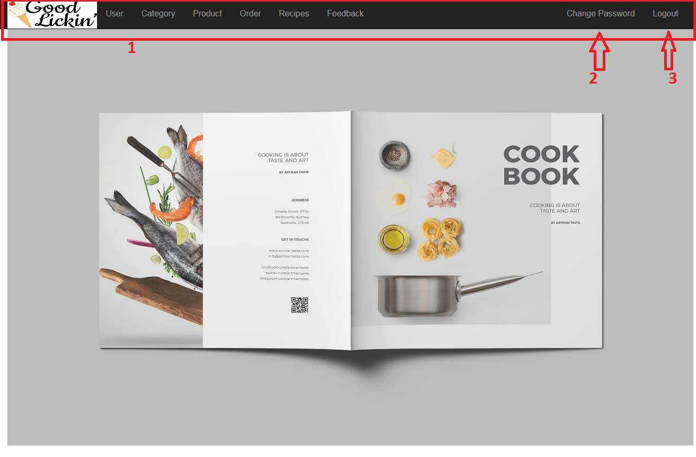

|  |  |  |  |  |  |  |
| --- | --- | --- | --- | --- | --- | --- |
| **No** | **Name** | **Type** | **Validation** | **Event** | **Description** | **Status** |
| 1 | Navigation Bar | Hyperlink |  | Click | Click to go to management pages | Enable |
| 2 | Change Password | Hyperlink |  | Click | Click to go to change password page | Enable |
| 3 | Logout | Hyperlink |  | Click | Click to logout | Enable |

* 1. **Category Management Page:** Admin can manage product here

**2.5.1. Add new Category:** Create category form for admin

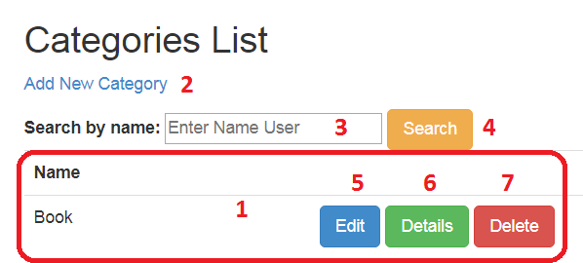

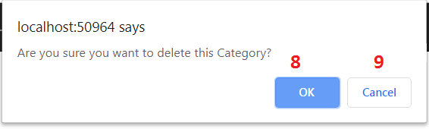

|  |  |  |  |  |  |  |
| --- | --- | --- | --- | --- | --- | --- |
| **No** | **Name** | **Type** | **Validation** | **Event** | **Description** | **Status** |
| 1 | Category List | Table |  |  | List of Category | Enable |
| 2 | Add New Category | Hyperlink |  | Click | Click to go to add new category page | Enable |
| 3 | txtSearch | Textbox |  | Click | Input name of Search to search | Enable |
| 4 | btnFilter | Button |  | Click | Click to search product | Enable |
| 5 | Edit | Hyperlink |  | Click | Click to go to edit category page | Enable |
| 6 | Details | Hyperlink |  | Click | Click to go to product details page | Enable |
| 7 | Delete | Hyperlink |  | Click | Process to delete product | Enable |
| 8 | btnOk | Button |  | Click | Click to delete product | Enable |
| 9 | btnCancel | Button |  | Click | Click to return | Enable |

* + 1. **Add new Category:** Create category form for admin

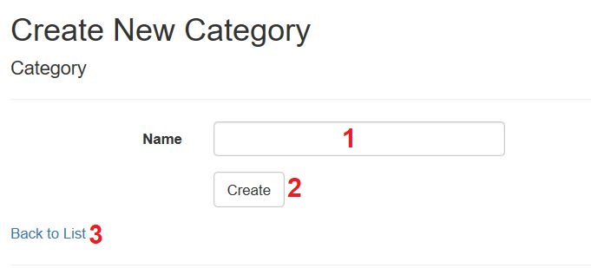

|  |  |  |  |  |  |  |
| --- | --- | --- | --- | --- | --- | --- |
| **No** | **Name** | **Type** | **Validation** | **Event** | **Description** | **Status** |
| 1 | txtCateName | Textbox | - Not null - Max length:50 | Focus | Input category name | Enable |
| 2 | btnSubmit | Button |  | Click | Click to add new category | Enable |
| 3 | Back to list | Hyperlink |  | Click | Click to go back category list | Enable |

* + 1. **Edit Category:** Edit category form for admin

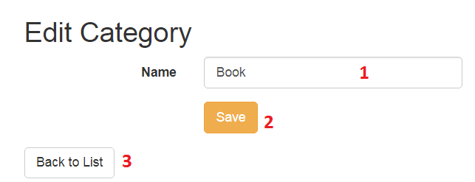

|  |  |  |  |  |  |  |
| --- | --- | --- | --- | --- | --- | --- |
| **No** | **Name** | **Type** | **Validation** | **Event** | **Description** | **Status** |
| 1 | txtCateName | Textbox | - Not null - Max length:50 | Focus | Input to edit category name | Enable |
| 2 | btnSubmit | Button |  | Click | Click to edit category | Enable |
| 3 | Back to list | Hyperlink |  | Click | Click to go back category list | Enable |

* + 1. **Details of Category:** This page display details of a category

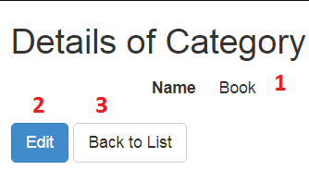

|  |  |  |  |  |  |  |
| --- | --- | --- | --- | --- | --- | --- |
| **No** | **Name** | **Type** | **Validation** | **Event** | **Description** | **Status** |
| 1 | txtCateName | Textbox  (Read only) |  |  | Category’s name | Enable |
| 2 | Edit | Hyperlink |  | Click | Click to go to edit category page | Enable |
| 3 | Back to list | Hyperlink |  | Click | Click to go back category list | Enable |

* 1. **Product Management Page:** Admin can manage product here
     1. **Manage Product List:** Display list of product, admin can create, view details, edit or delete a product from here.

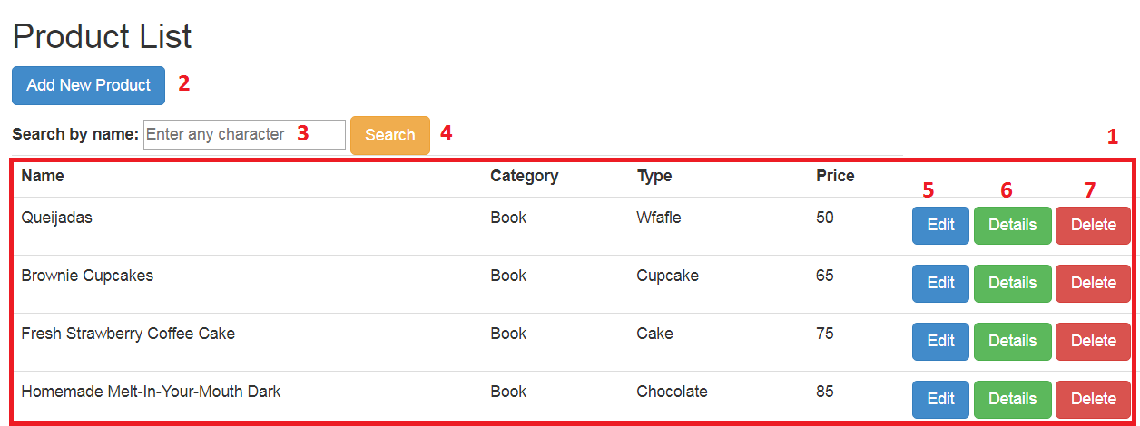

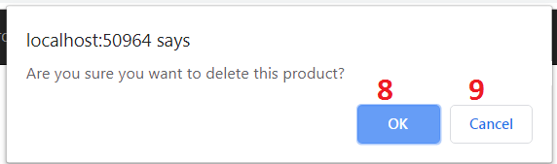

|  |  |  |  |  |  |  |
| --- | --- | --- | --- | --- | --- | --- |
| **No** | **Name** | **Type** | **Validation** | **Event** | **Description** | **Status** |
| 1 | Product List | Table |  |  | List of products | Enable |
| 2 | Add New | Hyperlink |  | Click | Click to go to add new product page | Enable |
| 3 | txtSearch | Textbox |  | Click | Input name of product to search | Enable |
| 4 | btnFilter | Button |  | Click | Click to search product | Enable |
| 5 | Edit | Hyperlink |  | Click | Click to go to edit product page | Enable |
| 6 | Details | Hyperlink |  | Click | Click to go to product details page | Enable |
| 7 | Delete | Hyperlink |  | Click | Process to delete product | Enable |
| 8 | btnOk | Button |  | Click | Click to delete product | Enable |
| 9 | btnCancel | Button |  | Click | Click to return | Enable |

* + 1. **Add new Product:** Create product form for admin

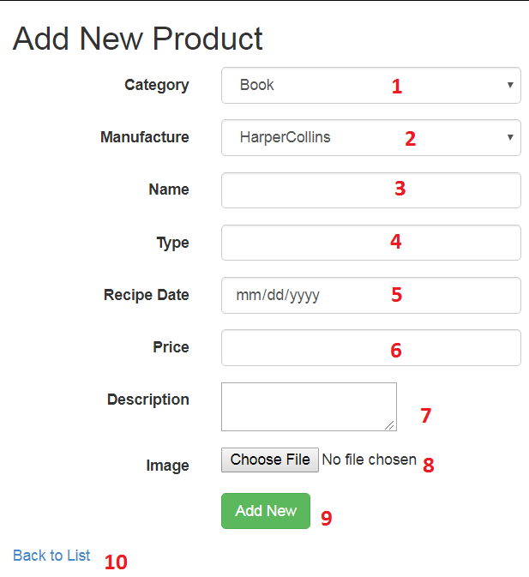

|  |  |  |  |  |  |  |
| --- | --- | --- | --- | --- | --- | --- |
| **No** | **Name** | **Type** | **Validation** | **Event** | **Description** | **Status** |
| 2 | ddCategory | Dropdown List | Not Null | Focus | Choose name of category | Enable |
| 1 | ddManufacture | Dropdown List | Not Null | Focus | Choose name of manufacture | Enable |
| 3 | txtProductName | Textbox | - Not null - Max length:50 | Focus | Input product name | Enable |
| 4 | txtType | Textbox | - Not null - Max length:50 | Focus | Input product type | Enable |
| 5 | Date | Calendar | Not Null | Focus | Input product recipe date | Enable |
| 6 | txtPrice | Textbox | - Not null - From 1 to 10000 | Focus | Input product price | Enable |
| 7 | txtDescription | Textbox | - Not null - Max length:1000 | Focus | Input product description | Enable |
| 8 | fuImage | File Upload | Not null | Focus | Upload product image | Enable |
| 9 | btnSubmit | Button |  | Click | Click to add new product | Enable |
| 10 | Back to List | Hyperlink |  | Click | Click to return product list | Enable |

* + 1. **Product Details:** This page display details of a product

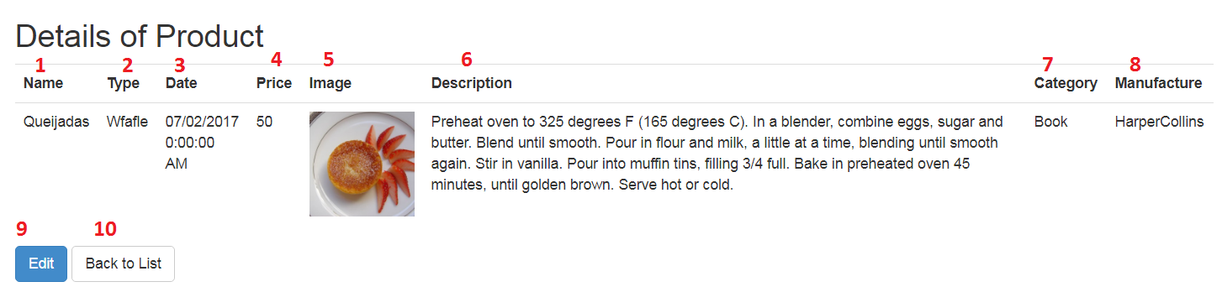

|  |  |  |  |  |  |  |
| --- | --- | --- | --- | --- | --- | --- |
| **No** | **Name** | **Type** | **Validation** | **Event** | **Description** | **Status** |
| 1 | Product Name | Textbox (Read only) |  |  | Product’s name | Enable |
| 2 | Type | Textbox (Read only) |  |  | Product’s type | Enable |
| 3 | Date | Calendar (Read only) |  |  | Product’s recipe date | Enable |
| 4 | Price | Textbox (Read only) |  |  | Product’s price | Enable |
| 5 | Image | Image (Read only) |  |  | Product’s image | Enable |
| 6 | Description | Textbox (Read only) |  |  | Product’s description | Enable |
| 7 | Category Name | Dropdown List |  |  | Category’s Name | Enable |
| 8 | Manufacture Name | Dropdown List |  |  | Manufacture’s Name | Enable |
| 9 | Edit | Hyperlink |  | Click | Click to go to edit product page | Enable |
| 10 | Back to List | Hyperlink |  | Click | Click to return product list | Enable |

* + 1. **Edit Product:** Edit product form for admin

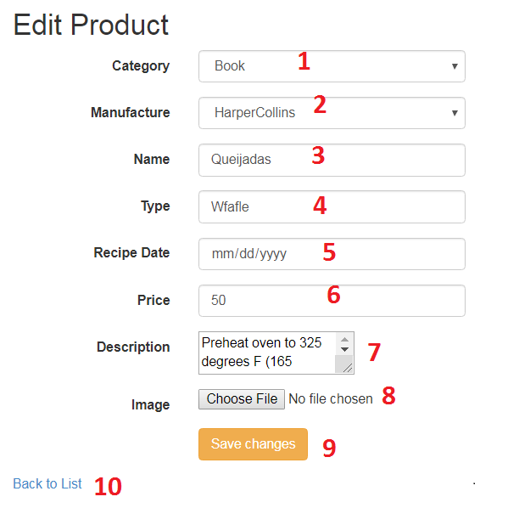

|  |  |  |  |  |  |  |
| --- | --- | --- | --- | --- | --- | --- |
| **No** | **Name** | **Type** | **Validation** | **Event** | **Description** | **Status** |
| 2 | ddCategory | Dropdown List | Not Null | Focus | Choose name of category | Enable |
| 1 | ddManufacture | Dropdown List | Not Null | Focus | Choose name of manufacture | Enable |
| 3 | txtProductName | Textbox | - Not null - Max length:50 | Focus | Input product name | Enable |
| 4 | txtType | Textbox | - Not null - Max length:50 | Focus | Input product type | Enable |
| 5 | Date | Calendar | Not Null | Focus | Input product recipe date | Enable |
| 6 | txtPrice | Textbox | - Not null - From 1 to 10000 | Focus | Input product price | Enable |
| 7 | txtDescription | Textbox | - Not null - Max length:1000 | Focus | Input product description | Enable |
| 8 | fuImage | File Upload | Not null | Focus | Upload product image | Enable |
| 9 | btnSaveChanges | Button |  | Click | Click to edit product | Enable |
| 10 | Back to List | Hyperlink |  | Click | Click to return product list | Enable |

* 1. **User Management Page:** Admin can manage user here
     1. **Manage User List:** Display list of user, admin can create, view details user from here

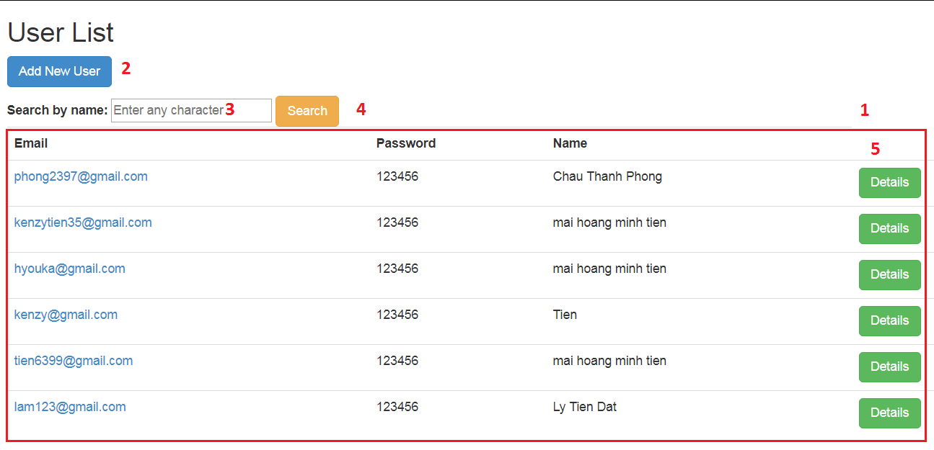

|  |  |  |  |  |  |  |
| --- | --- | --- | --- | --- | --- | --- |
| **No** | **Name** | **Type** | **Validation** | **Event** | **Description** | **Status** |
| 1 | User List | Table |  |  | List of user | Enable |
| 2 | Add New | Hyperlink |  | Click | Click to go to add new user page | Enable |
| 3 | txtSearch | Textbox |  | Click | Input name of user to search | Enable |
| 4 | btnFilter | Button |  | Click | Click to search user | Enable |
| 5 | Details | Hyperlink |  | Click | Click to go to user details page | Enable |

* + 1. **Add New User:** Create user form for admin

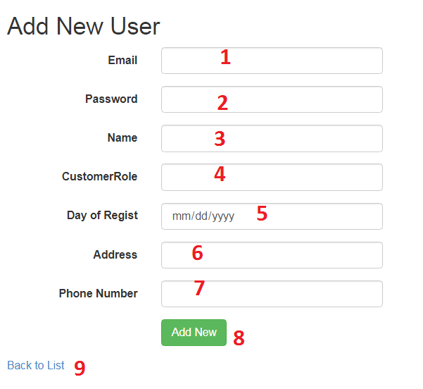

|  |  |  |  |  |  |  |
| --- | --- | --- | --- | --- | --- | --- |
| **No** | **Name** | **Type** | **Validation** | **Event** | **Description** | **Status** |
| 1 | txtEmail | Textbox | - Not null -DataType EmailAddress | Focus | Input email | Enable |
| 2 | txtPassword | Textbox | - Not null - Max length:50 | Focus | Input password | Enable |
| 3 | txtName | Textbox | - Not null - Max length:50 | Focus | Input user’s full name | Enable |
| 4 | txtRole | Textbox |  | Focus | Input value role member | Enable |
| 5 | txtDayofRegist | Calendar |  | Focus | Input user’s register | Enable |
| 6 | txtAddress | Textbox | - Not null - Max length:50 | Focus | Input user’s address | Enable |
| 7 | txtPhone | Textbox | - Not null - Max length:15 | Focus | Input user’s phone number | Enable |
| 8 | btnSubmit | Button |  | Click | Click to add new user | Enable |
| 9 | Back to List | Hyperlink |  | Click | Click to return user list | Enable |

* + 1. **User Details:** This page display details of a user

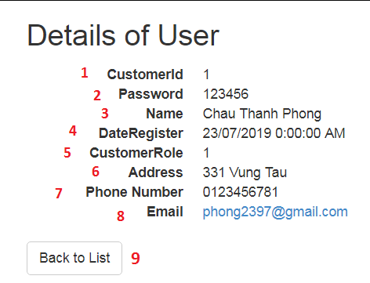

|  |  |  |  |  |  |  |
| --- | --- | --- | --- | --- | --- | --- |
| **No** | **Name** | **Type** | **Validation** | **Event** | **Description** | **Status** |
| 1 | txtCustomerId | Textbox (Read only) |  | Focus | Username | Enable |
| 2 | txtPassword | Textbox (Read only) |  | Focus | Password | Enable |
| 3 | txtName | Textbox (Read only) |  | Focus | User’s full name | Enable |
| 4 | txtDayofRegist | Textbox (Read only) |  | Focus | User’s Regist | Enable |
| 5 | txCustomerRole | Textbox (Read only) |  | Focus | User’s Role | Enable |
| 6 | txtAddress | Textbox (Read only) |  | Focus | User’s address | Enable |
| 7 | txtPhone | Textbox (Read only) |  | Focus | User’s phone number | Enable |
| 8 | txtEmail | Textbox (Read only) |  | Focus | User’s email | Enable |
| 9 | Back to List | Hyperlink |  | Click | Click to return user list | Enable |

* 1. **Order Management Page:** Admin can manage order here
     1. **Manage Order List:** Display list of order, admin can view details an order from here

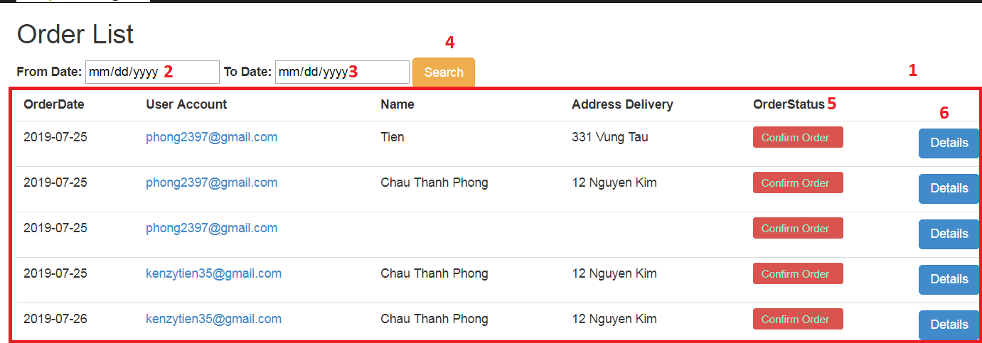

|  |  |  |  |  |  |  |
| --- | --- | --- | --- | --- | --- | --- |
| **No** | **Name** | **Type** | **Validation** | **Event** | **Description** | **Status** |
| 1 | Order List | Table |  |  | List of order | Enable |
| 2 | txtdFrom | Textbox |  | Focus | Input start date want to search | Enable |
| 3 | txtdTo | Textbox |  | Focus | Input end date want to search | Enable |
| 4 | btnFilter | Button |  | Click | Click to search order | Enable |
| 5 | BtnStatus | Button |  | Click | Click to update status order | Enable |
| 6 | Details | Hyperlink |  | Click | Click to go to order details page | Enable |

* + 1. **Order Details Page:** This page display details of an order

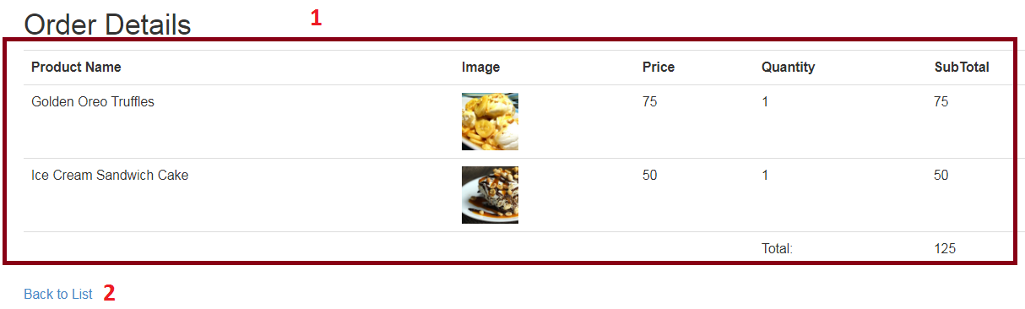

|  |  |  |  |  |  |  |
| --- | --- | --- | --- | --- | --- | --- |
| **No** | **Name** | **Type** | **Validation** | **Event** | **Description** | **Status** |
| 1 | Order Details List | Table |  |  | Order details of 1 order | Enable |
| 2 | Back to List | Hyperlink |  | Click | Click to return order list | Enable |

* 1. **Feedback Management Page:** Admin can manage feedback here
     1. **Feedback List:** Display list of feedback, view details, recipe from here

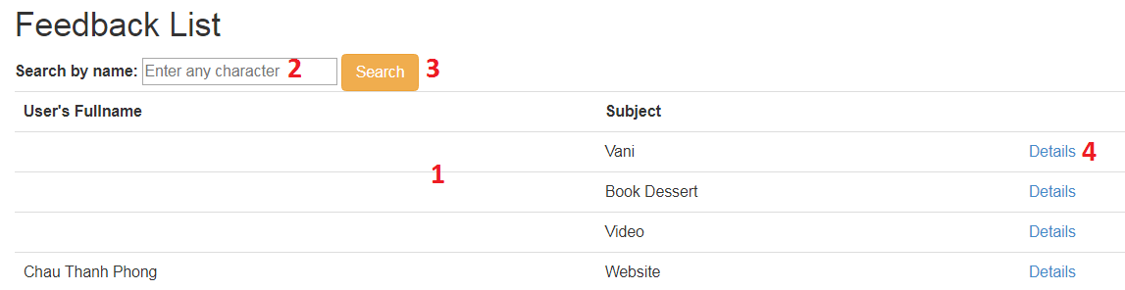

|  |  |  |  |  |  |  |
| --- | --- | --- | --- | --- | --- | --- |
| **No** | **Name** | **Type** | **Validation** | **Event** | **Description** | **Status** |
| 1 | Feedback List | Table |  |  | List of feedbacks | Enable |
| 2 | txtSearch | Textbox |  | Focus | Input user’s full name to search feedback | Enable |
| 3 | btnFilter | Button |  | Click | Click to search feedback | Enable |
| 4 | Details | Hyperlink |  | Click | Click to go to details & delete feedback page | Enable |

* + 1. **Details Feedback:** Display details of a feedback’s user.

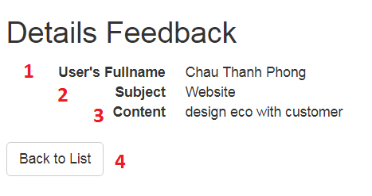

|  |  |  |  |  |  |  |
| --- | --- | --- | --- | --- | --- | --- |
| **No** | **Name** | **Type** | **Validation** | **Event** | **Description** | **Status** |
| 1 | txtUsername | Textbox (Read only) |  | Focus | Username | Enable |
| 2 | txtSubject | Textbox (Read only) |  | Focus | Feedback’s Subject | Enable |
| 3 | txtContent | Textbox (Read only) |  | Focus | Feedback’s Content | Enable |
| 4 | Back to List | Hyperlink |  | Click | Click to return feedback list | Enable |

* 1. **Recipes Manage Page:** Admin can manage recipe in here
     1. **Recipes List:** Display list of Recipe, admin can view details,edit or delete a feedback from here

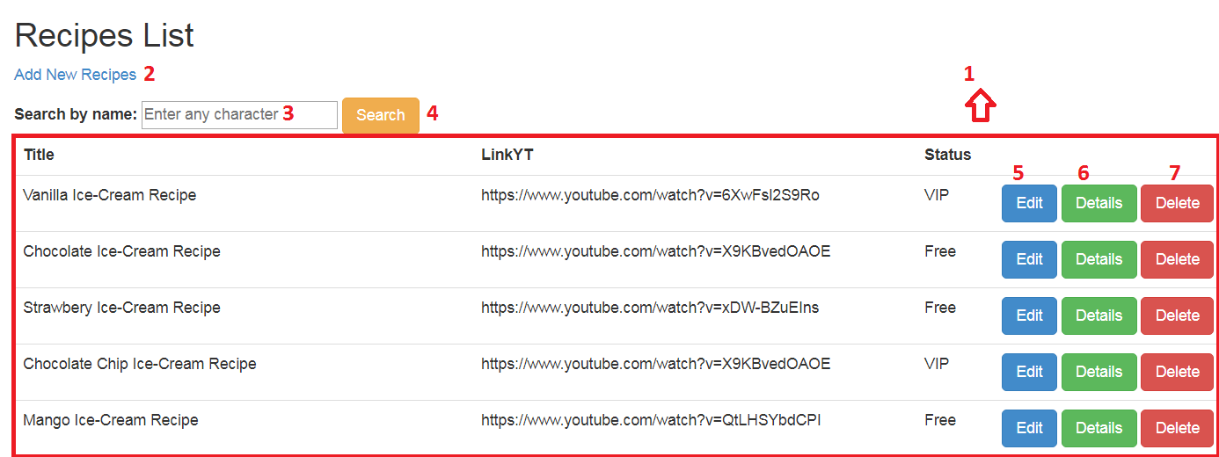

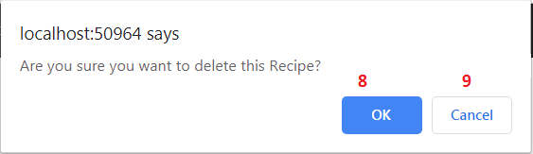

|  |  |  |  |  |  |  |
| --- | --- | --- | --- | --- | --- | --- |
| **No** | **Name** | **Type** | **Validation** | **Event** | **Description** | **Status** |
| 1 | Recipe List | Table |  |  | List of Recipe | Enable |
| 2 | Add New | Hyperlink |  | Click | Click to go to add new recipes page | Enable |
| 3 | txtSearch | Textbox |  | Click | Input name of recipe to search | Enable |
| 4 | btnFilter | Button |  | Click | Click to search recipe | Enable |
| 5 | Edit | Hyperlink |  | Click | Click to go to edit recipe page | Enable |
| 6 | Details | Hyperlink |  | Click | Click to go to recipe details page | Enable |
| 7 | Delete | Hyperlink |  | Click | Process to delete recipe | Enable |
| 8 | btnOk | Button |  | Click | Click to delete recipe | Enable |
| 9 | btnCancel | Button |  | Click | Click to return | Enable |

* + 1. **Add new Recipes:** Create Recipes form for admin

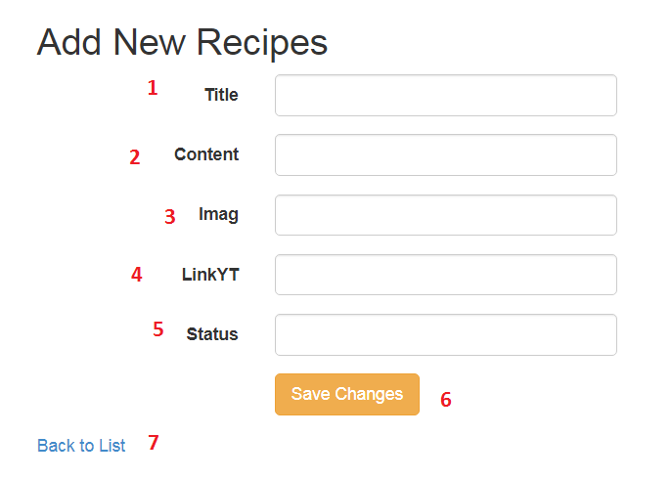

|  |  |  |  |  |  |  |
| --- | --- | --- | --- | --- | --- | --- |
| **No** | **Name** | **Type** | **Validation** | **Event** | **Description** | **Status** |
| 1 | txtTitle | Textbox |  | Focus | Input Title | Enable |
| 2 | txtContent | Textbox |  | Focus | Input Content | Enable |
| 3 | Imag | Textbox |  | Focus | Choose File Image of recipe | Enable |
| 4 | txtLinkYT | Textbox |  | Focus | Input Link | Enable |
| 5 | txtStatus | TextBox |  | Focus | Input Status of Recipe | Enable |
| 6 | btnSubmit | Button |  | Click | Click to add new recipe | Enable |
| 7 | Back to List | Hyperlink |  | Click | Click to return recipe list | Enable |

* + 1. **Edit Recipes:** Edit Recipe form for admin

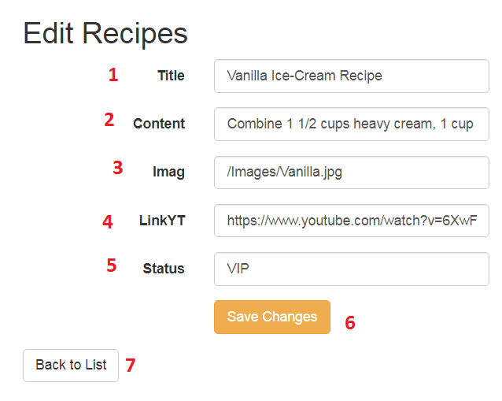

|  |  |  |  |  |  |  |
| --- | --- | --- | --- | --- | --- | --- |
| **No** | **Name** | **Type** | **Validation** | **Event** | **Description** | **Status** |
| 1 | txtTitle | Textbox  (Read Only) |  | Focus | Input Title | Enable |
| 2 | txtContent | Textbox  (Read Only) |  | Focus | Input Content | Enable |
| 3 | Imag | Textbox |  | Focus | Input link Image | Enable |
| 4 | txtLinkYT | Textbox  (Read Only) |  | Focus | Input Link | Enable |
| 5 | txtStatus | Textbox  (Read Only) |  | Focus | Input Status of Recipe | Enable |
| 8 | btnSubmit | Button |  | Click | Click to add new recipe | Enable |
| 9 | Back to List | Hyperlink |  | Click | Click to return recipe list | Enable |

* + 1. **Details of Recipes:** This page display details of a Recipes

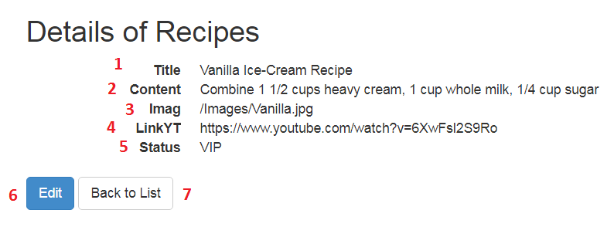

|  |  |  |  |  |  |  |
| --- | --- | --- | --- | --- | --- | --- |
| **No** | **Name** | **Type** | **Validation** | **Event** | **Description** | **Status** |
| 1 | txtTitle | Textbox  (Read Only) |  | Focus | Title | Enable |
| 2 | txtContent | Textbox  (Read Only) |  | Focus | Content | Enable |
| 3 | Imag | Textbox |  | Focus | Link Image | Enable |
| 4 | txtLinkYT | Textbox  (Read Only) |  | Focus | Link | Enable |
| 5 | txtStatus | Textbox  (Read Only) |  | Focus | Status of Recipe | Enable |
| 6 | Edit | Hyperlink |  | Click | Click to return edit recipe | Enable |
| 7 | Back to List | Hyperlink |  | Click | Click to return recipe list | Enable |

1. **SITE MAP**
2. **Back-End Site Map**

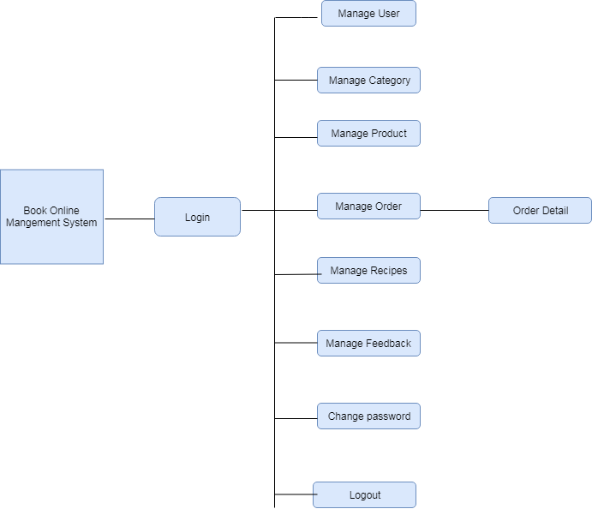

1. **Front-End Site Map**

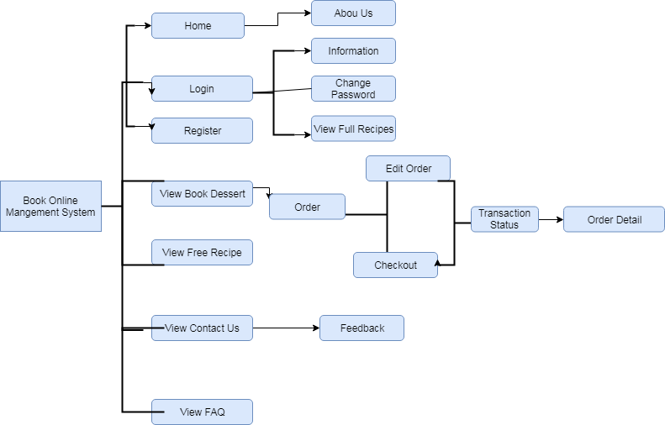

1. **TEST PLAN/TEST CASE**

|  |  |  |  |  |
| --- | --- | --- | --- | --- |
| **Test** | **What is being tested** | **How** | **Test data used** | **Expected Results** |
| 1 | Order of input on data entry screen | Enter data from data capture sheet into the form on the data entry screen | Data set 1 | Data entry order is the same as that on the data capture sheet |
| 2 | Validation of input | Enter typical values, boundary value, values that should be rejected | Data set 2 | Good data accepted, bad data rejected |
| 3 | Accurate calculations |  | Data set 3 | Data set 3A |
| 4 | Scaled output |  | Data set 4 | Paginated output |

1. **CHECKLIST OF VALIDATIONS**

|  |  |
| --- | --- |
| **Option** | **Validated** |
| Do all numeric variables have a default value of zero? | Yes |
| Does the administrator have all the rights to create and delete the records? | Yes |
| Are all the records properly fed into the appropriate database? | Yes |
| Have all the modules been properly integrated and are completely functional? | Yes |
| Have all the design and coding standards been followed and implemented? | Yes |
| Is the design consistent all over? | Yes |
| Is the navigation sequence correct through all the screens in the application? | Yes |
| Is exception handling mechanism implemented in all the screens? | Yes |
| Are all the program codes working? | Yes |

1. **SUBMISSION CHECKLIST**

|  |  |  |  |  |  |
| --- | --- | --- | --- | --- | --- |
| **Sr.No.** | **Particulars** | **Yes** | **No** | **NA** | **Comments** |
| 1 | Have all the modules been properly integrated and are they completely functional? | Yes |  |  |  |
| 2 | Does each unit meet its objective and purpose?  Are all the validations happening as specified in Process Design? | Yes |  |  |  |
| 3 | Have all Design and Coding standards been followed and implemented? | Yes |  |  |  |
| 4 | Is the GUI design consistent all over? | Yes |  |  |  |
| 5 | Are the codes working as per the specification? | Yes |  |  | . |
| 6 | Does the application’s functionality resolve the client problem, and satisfy his/her needs completely? | Yes |  |  |  |
| 7 | Have the hardware and software been correctly chosen? | Yes |  |  |  |
| 8 | Additional features and utilities that give value addition to the entire project. | Yes |  |  |  |

# TASK SHEET REVIEW 3

|  |  |  |  |  |  |  |  |  |
| --- | --- | --- | --- | --- | --- | --- | --- | --- |
| **Project Ref. No.:**  **Airlines Reservation System** | | **Project Title:** | **Activity Plan Prepared By:** | **Date of Preparation of Activity Plan:** | | | | |
| **Sr.No.** | **Task** | **Actual Start Date** | **Actual Days** | **Team Mate Names** | | **Status** |
| 1 | Admin Site Map | Ice Cream Shop  Management System | Bui Van Huong | 15/07/2019 | 1 | Chau Thanh Phong | | Completed |
| 2 | Client Site Map | Mai Hoang Minh Tien | | Completed |
| **Client Pages** | |  | | | | |
| 3 | Login Page | 21/07/2019 | 1 | Mai Hoang Minh Tien | | Completed |
| 4 | Dashboard Page | 1 | Bui Van Huong | | Completed |
| 5 | Register Page | 1 | Mai Hoang Minh Tien | | Completed |
| 6 | Members Page | 1 | Mai Hoang Minh Tien | | Completed |
| 7 | Change Password Page | 22/07/2019 | 5 | Mai Hoang Minh Tien | | Completed |
| 8 | Product Book Page | Chau Thanh Phong | | Completed |
| 9 | Detail Book Page | Chau Thanh Phong | | Completed |
| 10 | Shopping Cart Page | 26/07/2019 | 4 | Chau Thanh Phong | | Completed |
| 11 | Order Page | 4 | Chau Thanh Phong | | Completed |
| 12 | Detail Order Page | 2 | Chau Thanh Phong | | Completed |
| 13 | Free Recipes Page | 27/07/2019 | 1 | Ly Tien Dat | | Completed |
| 14 | Full Recipes Page | 1 | Ly Tien Dat | | Completed |
| 15 | Detail Recipes Page | 28/07/2019 | 2 | Ly Tien Dat | | Completed |
| 16 | Feedback Page | 28/07/2019 | 1 | Dang Nguyen Dan Linh | | Completed |
| 17 | FAQ Page | 29/07/2019 | 1 | Dang Nguyen Dan Linh | | Completed |
| **Admin Pages** | |  | | | | |
| 13 | Login Page | 25/07/2019 | 1 | Bui Van huong | Completed | |
| 14 | Dashboard Page | Completed | |
| 15 | Change Password Page | Completed | |
| 16 | User Page | 29/07/2019 | 2 | Chau Thanh Phong | Completed | |
| 17 | Category Page | Completed | |
| 18 | Product page | Completed | |
| 19 | Order page | Completed | |
| 20 | Recipes Page | Completed | |
| 21 | Feedback page | Completed | |

|  |  |
| --- | --- |
| **Date:** | |
| Signature of Instructor:  **MS. Le Mong Thuy** | Signature of Team Leader:  **Bui Van Huong** |